

Newsletter No 3 – 1st October

kindness…respect…tolerance…fairness…achievement…happiness…being included…being listened to…
Our vision for Oyne School is for happy achieving children to be supported to do their very best learning within a caring school and community.

Dear Parents and Carers,
As we move towards the end of this first short term, everyone can be pleased that they have started the year so well. The new pupils in the school are confident and settled well to all the new routines and ways of working. They have been learning letters and numbers as well as how to get on in a large group of other children. The P3/4s have risen to the challenge of the higher standards expected of them. Especially the P3s who have to work hard to get used to learning in jotters rather than workbooks. In P5/6/7 pupils have developed a more mature approach to learning and are approaching things with enthusiasm and endeavour.

The Annual Standards and Quality report for the school is attached. Please return the slip below if you have any comments.

Well done everyone!

Regards
Sharon Huxtable
Headteacher

  …their very best learning…  Techfest  We all had a fabulous day at Techfest. Its great to go as a whole school and all the pupils learned lots and enjoyed themselves while doing it!  Everyone went to three workshops. Here are some of the highlights.  P3/4 learned all about flight, and the weather.  P1/2 created clouds and had some close encounters with rainforest animals.  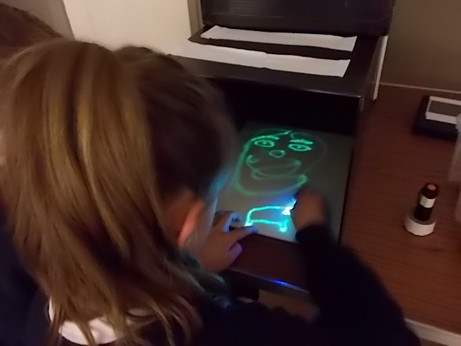  P5/6/7 investigated infra red light and breaking up light at the light lab. As well as loads more! | …within a caring school and community.  Oyne Ospreys  Our Jogging club is going from strength to strength. They look great in their new running kit. Many thanks to Oyne Community Association for their donation to start us off with that.  The Running Race at the Back of Bennachie was a great success and everyone enjoyed themselves. Hopefully the first of many such events hosted by Oyne on our favourite hill!

The next instalment for the P6/7 trip to Dalguise is due at the end of October


Safety Notices

Can I please remind parents to keep a close eye on their younger children at the beginning and end of the day and particularly to ensure that they don’t run through the carpark or climb on the small car park wall. Cars could be arriving and manouevring at any time and the small wall is not built for climbers.

School Security

Please be aware that it may take some time to answer the door when the office is unattended. Please ring the bell, someone will talk to you through the intercom so please speak clearly to identify your self or someone will come to let you in in person.
Useful Information  Read, write, count is a new website to support literacy and numeracy for P1 – P3 pupils and their parents.  http://www.readwritecount.scot/  There are a wide range of Ranger Services and Activities available over October at different locations please email garioch.ranger@aberdeenshire.gov.uk  for further details  Please note letter from NHS Grampian about Free Eye Examinations attached to this newsletter |   Harvest Celebration  We are delighted to have the Rev Dr Kay Gauld the new minister for Insch-Leslie-Premnay-Oyne to lead our Harvest Celebration on Friday October 2nd. Please note the start time of 2.15pm which has changed from previous newsletters. P1/2 are continuing to collect dried foods and tins for the Cyrenians.
Parent Council

Many thanks to Fiona Barber who volunteered to take up the secretarial role for the parent council.

A huge well done to everyone involved in planning and organising the Harvest Hoolie. The event raised an amazing £3000+ and was a brilliant night for all who attended. Particular thanks to Annie Duncan for all her hard work in pulling it all together.

Watch out for the Parent Council newsletter which will keep you up to date with all the parent council news as well as the Parent Council facebook page.

The consultation around the Parent Council Constitution finishes next week. If you have any comments please pass to Tricia Barnett or leave them at the school.

Barnardos Boxes
Mrs Phillipa Buckingham stood in for Kit at the Barnardos assembly last week. She shared the development of the charity with the pupils and some fascinating pictures of children at the time. If you would still like to take a Barnardos box please contact the school office.

PTA events
Look out for further news ….
Halloween Disco Party – Sunday 1st November
Festive Fayre – Saturday 28th November

After School Activities

Jogging will restart on Monday 26th October and run for the first 3 weeks of term – it will stop at the mid-term break and restart during Term 3 once the days are longer and the weather better.

Football will restart on Friday 6th November and run every Friday for 6 weeks (last session on Friday 11th December) in the village hall, week about for the juniors and seniors – juniors on the 6th, seniors on the 13th and so on.

Badminton will start on Monday 26th October and run most Mondays during the term. There will be no badminton on 16th November and 7th December. It will take place in Chapel of Garioch Hall from 6-7 pm. Parents will need to register their children using the online system so that their details are available for the register.

Thank you to everyone who registered their children online for jogging and football this term-it saved a lot of paperwork here in school and means that their details are available for the whole year for those running jogging and football (and badminton once they’ve registered for that!). If you haven’t registered online and would prefer a paper form, please ask for one from the office. It is very important that those running the groups have all the relevant details for your child in case of any problems or if they need to contact you in an emergency so please ensure you do add them. The link for the system has changed since we circulated it previously – it can be found at:

http://www.aberdeenshire.gov.uk/leisure-sport-and-culture/active-schools/in-your-area/garioch/inverurie-primary-network/

Diary Dates
Fri 2nd Oct | Harvest Assembly | 2.15pm – all welcome
Wed 7th Oct | Parent Interviews | 3.30 – 5.00pm and 6.00 – 8.30pm
Mon 12th Oct – Fri 23th Oct | October Holidays
Wed 28th Oct | Hopscotch Theatre visit
Mon 16th and Tue 17th Nov | In Service Days 2 & 3
Tue 8th and Wed 9th Dec | Christmas Performances | 7.00pm – all welcome
Wed 23rd Dec – Tue 5th Jan (inclusive) | Christmas Holidays
Fri 12th Feb | Occasional Holiday
Mon 15th Feb | Spring Midterm holiday
Tues 16th and Wed 17th Feb | In Service Days 4 & 5
Tues 1st Mar | Open Afternoon Event | 2.00pm onwards – all welcome
Wed 23rd Mar | School Reports issued
Fri 25th Mar | Good Friday Holiday
Wed 30th Mar | Parent Interviews | 3.30 – 5.00pm and 6.30 – 8.30pm
Mon 4th April – Fri 15th April | Spring Holidays
Mon 2nd May | May Day Holiday
Thu 2nd June | Sports Day | 2.00pm – all welcome
Mon 6th June | Occasional Holiday
Thur 30th June | End of Year Assembly | 2.00pm – all welcome
Fri 1st July | Last day of school year


Oyne School Standards and Quality Report Comments

Signed…………………………………………………………….Date……………………….


Football Boots

Please be reminded that pupils who play football in school or after school should not be wearing boots with metal studs at any time. When playing football on the grass during school playtimes outdoor trainers are suitable. When playing football at the after school club moulded shoes (plastic, rubber, rounded, bladed or Astroturf boots) are suitable. Shinpads are also required for after school football and trainers will be worn when playing indoors.

:::::::::::::::::::::::::::::::::::::::::::::::::::::::::::::::::::::::::::::::::::::::::::::::::::::::::

Please sign and return this slip

Child/ren’s Name…………………………………………

I have read and understood the contents of this slip

Name………………………………………………Date…………………

