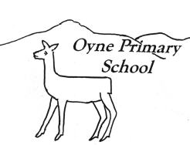
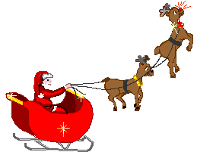
Newsletter Update
No 5b – 15th December

kindness…respect…tolerance…fairness…achievement…happiness…being included…being listened to…
Our vision for Oyne School is for happy achieving children to be supported to do their very best learning within a caring school and community.

Dear Parents, Carers and friends,
Just a quick catch up to let you know what is happening for the last few days of term. Thank you for all your kind gifts and cards and support throughout 2015. Happy Christmas and and a happy and healthy 2016 to all.
Sharon Huxtable
Headteacher


Our Christmas List

Thursday 17th December
Christmas Story Morning – Senior pupils share Christmas books they have written with the other pupils
Christmas Craft Afternoon – Whole school afternoon of working together (and sticking and making)
Friday 18th December
Christmas Jumper Day – Pupils are invited to wear a Christmas Jumper (or something else they like) and bring in a donation (£1) to Text Santa
Christmas Assembly – Dr Rev Kay Gauld will join us for our school assembly
Monday 21st December
Christmas Party Lunch – Pupils get a ….
Christmas Party. Pupils should wear school uniform into school and can change into party clothes if they wish at lunch time.
Tuesday 22nd December
Last day of term
Whole School Film afternoon – popcorn and juice provided.



We all enjoyed a visit from baby Wyatt and Mrs Duckers yesterday.

