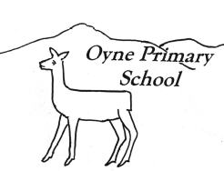
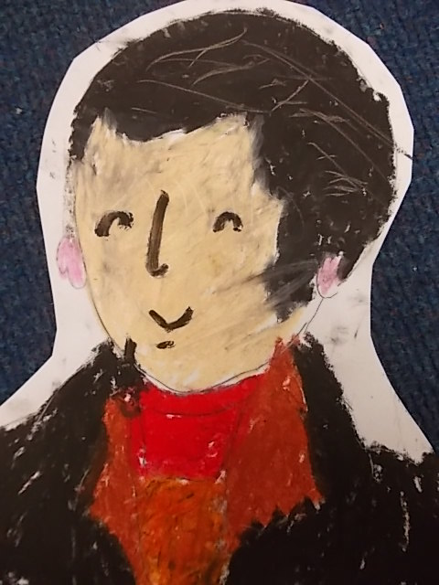
Newsletter No 7 – 4th February 2016

Robert Burns
by Olivia McGuire
kindness…respect…tolerance…fairness…achievement…happiness…being included…being listened to…
Our vision for Oyne School is for happy achieving children to be supported to do their very best learning within a caring school and community.

Dear Parents, Carers and friends,
Welcome to the February Newsletter. Each month is full of activities at this time of year - which is just as well as it distracts us all from wet playtimes and muddy fields. The children have had visitors to enhance their learning and at both ends of the school we are thinking about transition both into and out of primary education. Feedback from both areas of transition is always positive and I have no doubt that both our new P1s and our old P7s will start their new school experience in August well prepared and ready for the next stage. We also welcome back Jakob Ipsen into P7 and welcome Naomi Ferrier into P4, we hope that they will enjoy their time (back) with us. Meanwhile there is Chinese New Year, Pancake Day, Burns, Great Garden Bird Watch, Internet Safety day etc to fit in – not to mention getting ready for reporting – it’s a good job there is a break in February for everyone to catch breath.
Sharon Huxtable
Headteacher

Our vision for Oyne School is for happy achieving children to be supported… within a caring school and community.


Parent Partnership
Safer Internet Day and Workshop
At Oyne School we take internet safety seriously and last year we invited the Police Liaison Officer into school to take workshops with parents and children. This year we are getting involved with Safer Internet Day on February 9th. Children will be taking part in activitites during the day that reinforce how we can all use digital technologies safely. In the evening on Wednesday February 10th (7.00 – 7.45pm) we are delivering a workshop for all parents. This will be short and informal and led by Trish Barnett and myself. It is an opportunity for parents of children of all ages to discuss their concerns and to look at the advice given to all of us who want our children to grow up safely and to use technology with confidence.
Parent Information
The National Parent Forum of Scotland have published a summary of the Government’s National Improvement Strategy
Here is the link
http://www.npfs.org.uk/wp-content/uploads/2016/01/NPFS_NIF_E-1.pdf
Parent Council
The next Parent Council meeting is on Wednesday 24th February at 7.00pm. The meetings are open to all parents and are a great way of finding out what is happening in the school. All are most welcome.
Burns Hoolie
The Burns Hoolie event was a great success. From entering into the beautiful room at Logie House to the swirling sounds of a lone piper, being welcomed with a glass of something fine, the wonderful traditional Scottish cuisine and the fantastic band Fusion who entertained all with their rocking sounds interspersed with the odd ceilidh number, all who attended had a great time. It must be said though that one of the highlights of the evening was the addressing of the haggis by Master of Ceremonies Richard Latimer and his charismatic poetry recital. Thanks go to Annie Duncan for once again arranging a sublime evening of entertainment. She in turn would like to thank all those who attended and made the evening so special. Approximately £2500 was raised to be shared between the PTA and the special nursery. (Special reporter – Trish Barnett)

Our vision for Oyne School is for happy achieving children to be supported… within a caring school and community.  Burns/Doric Poems  We have enjoyed celebrating Burns and Doric poetry over the last few weeks. Children have been learning and practising poems. The P7s recited (the whole of) the Address to a Haggis at our Burns lunch and everyone participated with enthusiasm in our Burns Assembly. We are looking forward to welcoming Mrs Hassan and Mrs McIntosh back to judge our poems this week. This was a successful event last year and everyone who took part enjoyed it. | Our vision for Oyne School is for happy achieving children …  Recorder Group  Mrs Taylor is doing a grand job with our new recorder group. Tuesday lunch times is always alive with the sound of tuneful tooting.  Well done everyone.

At Oyne School we value…happiness, being included, being listened to…  Learning and Teaching  This term we are all learning about biodiversity and interdependence. Pupils in P1/2 are looking at minibeasts. Thanks to Mr Kenyon (Emily’s Grandad) who came and shared some of his knowledge about minibeasts.  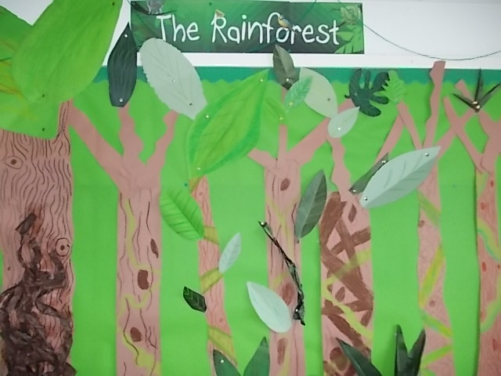  Pupils in p3/4 and P5/6/7 are looking at rainforests. | At Oyne School we value…being included, being listened to…  Pupil Voice Groups  Being listened to is one of our school values. Our Pupil Voice Groups are an important way of sharing and acting on pupil views and ideas.  Last week the Pupil Action Group discussed the different things that would make our playground a better place to be, they are excited about the idea of a friendship bench, they would like Playground Pals to help them play and they are keen to share an assembly and plan an afternoon in school with activities all about friendship.  The Eco Action Group have got lots of ideas to increase our biodiversity and they are hoping to encourage even more wildlife and minibeasts into our school.  The Health Action Group are hoping to encourage us all to eat more fruit with Fruity Fridays and fruit smoothies.

Our vision for Oyne School is for happy achieving children …  Skills for Learning, Life and Work  Last year we worked together to develop a School Curriculum Framework that reflected pupil and parent priorities as well as the Curriculum for Excellence. As a part of that we held an Active Assembly where we thought about the skills that we all need to live and work. Pupils identified literacy, and numeracy, teamwork, digital skills, communication skills as all being important in school and beyond and we worked together to create a display for the hall wall. | Our vision for Oyne School is for happy achieving children…  Visitors  We were delighted to welcome back Jackie from the SSPCA to deliver workshops and activities to all the classes. They all learned a bit more about the work of the SSPCA and about how to support wildlife.  Mrs Morrice was able to step in and man the ALEC caravan a day late because of the school closure and all the pupils had the opportunity to learn about their health and choices and how to look after themselves.

Our vision for Oyne School is for happy achieving children …  Active Schools  P5/6/7 have been enjoying Rugby training from Andy from the Garioch Rugby Club and later this term there will be opportunities for Football (P3-7) and Nordic Skiing (P5-7).  Rugby Training with P1/2 in Term 2 | Our vision for Oyne School is for happy achieving children to be supported… within a caring school and community.  Badminton  We were very proud of our Badminton players who represented the school at a recent competition at Portlethen. Seven pupils attended and played singles and doubles matches. All represented the school brilliantly and many thanks to the coaches Susie Miller, Tricia West and Graeme Barnett for giving up their time to lead the Badminton club.  Netball  Look out for Netball club information coming soon. Thanks to Steph Smith for taking this forward.
Burns Competition
A big thank you to Mrs Hassan and Mrs McIntosh who came to hear the Burns and Doric poems today. Everyone enjoyed performing and did a super job! Well done to everyone who took on the challenge!

Sainsbury’s Active Kids Vouchers
Sainsbury’s launched their annual Active Kids scheme on 27th January and vouchers are available in store until 3rd May – once again we will be accepting vouchers – please hand them in to the office, or pop them straight in the box outside the office door. Vouchers earn us sports and cooking equipment! Thank you!

Diary Dates
Tues 9th Feb | Safer Internet Day – School Focus
Wed 10th Feb | Safer Internet Day – Parent workshop | 7.00pm – All welcome
Fri 12th Feb | Occasional Holiday
Mon 15th Feb | Spring Midterm holiday
Tues 16th and Wed 17th Feb | In Service Days 4 & 5
Tues 1st Mar | Open Afternoon Event | 2.00pm onwards – all welcome
Wed 23rd Mar | School Reports issued
Fri 25th Mar | Good Friday Holiday
Wed 30th/Thu 31st Mar | Scholastic Book Fair
Wed 30th Mar | Parent Interviews | 3.30 – 5.00pm and 6.30 – 8.30pm
Mon 4th April – Fri 15th April | Spring Holidays
Mon 25th Apr – Fri 29th Apr | P6/7 residential trip to Dalguise
Mon 2nd May | May Day Holiday
Wed 4th May | Parent Council | 7.00pm – All welcome
Thu 2nd June | Sports Day | 2.00pm – all welcome
Mon 6th June | Occasional Holiday
Thur 30th June | End of Year Assembly | 2.00pm – all welcome
Fri 1st July | Last day of school year
Mon 15th Aug | In Service Day
Tuesday 16th Aug | First Day of new term | P1-7

