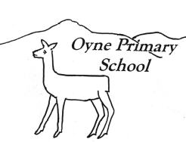

Newsletter No 8 – 2nd March 2016

World Book Day

kindness…respect…tolerance…fairness…achievement…happiness…being included…being listened to…
Our vision for Oyne School is for happy achieving children to be supported to do their very best learning within a caring school and community.

Dear Parents, Carers and friends,
We are all enjoying a bit more sunshine even though the wind is cold - hopefully spring is just around the corner. Of course as the weather is warmer the field is a bit more muddy – so please continue to make sure pupils have got lots of spare clothes. We’ve been enjoying the snow – just enough to play in – not too much to interrupt our school life! I hope you enjoy reading about all the activities that have taken place in February. There are even more for March and I hope you’ll agree that pupils at Oyne School get an enriched and lively curriculum whereever they are learning!
Sharon Huxtable
Headteacher

At Oyne School we value kindness…respect…tolerance…fairness…achievement…happiness…being included…being listened to…
Safer Internet Day and Workshop
Safer Internet Day was very successful for pupils and for parents. The pupils participated in a whole school assembly where the focus was what to do if they came across messages online that they didn’t like. In their own classes pupils looked at rules to keep them safe on line.
S – keep Safe, M – don’t arrange to Meet anyone you don’t know, - A – don’t Accept emails or files that you aren’t expecting, R – check if your information is Reliable, and T – Tell if you aren’t sure about anything you see online. SMART!
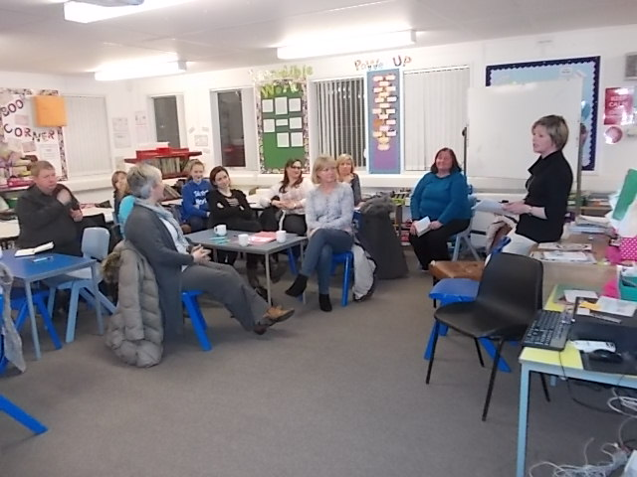

As a whole school we also brainstormed questions about how we use the internet and how it feels to have positive messages or hurtful messages and why we are all the same and all different. Parents met together for a workshop where the discussion was relaxed and informative. Thanks to Trish Barnett for leading and to all the parents who made contributions to the evening. Have a look at the display in the upper stages corridor for pupil and parent work.
Our vision for Oyne School is for happy achieving children to be supported to do their very best learning within a caring school and community.

Parent Interviews

Parent Interviews take place on Wednesday 30th March with the usual format. We will have a Scholastic Book Fair in the hall and parents and pupils are welcome to self-service refreshments and a browse. Pupils will be on hand to help out and collect our annual questionnaires. Pupil reports will come home on the previous week on Wednesday 23rd March. Please support pupils to complete the learner’s comments and return the back sheet with a parent comment as well. Please return the slip with parent interview preferences.
Community Film Afternoon

There will be a children’s film afternoon on Saturday March 11th at 3 pm the film is Bill (Horrible Histories) and the usual popcorn and snacks will be available. The film ‘The Lady in a Van’ is being shown in the evening 7.30 – 8.00pm. Tickets available from chris.dunridge@btinternet.com

Our vision for Oyne School is for happy achieving children to be supported… within a caring school and community.  Poetry Competition  We were delighted as always to welcome back Mrs Hassan and Mrs McIntosh to present certificates to the participants and winners of the recent poetry competition. Last year we had 26 pupils who entered the competition, this year 42 pupils had a go. Well done everyone!  The year group winners were  P1 Meghan Oliver  P2 Cameron Body  P3 Evie Ozanne  P4 Olivia McGuire  P5 Meg Barnett  P6 Chloe Barber  P7 Isla Mardon | Our vision for Oyne School is for happy achieving children …  Staff Updates  Miss Mowat is settling in well in P1/2 and we are expecting her to stay with us until Mrs Duckers’ expected return in October.  Mrs Buckingham and Mrs Milne recently undertook their refresher First Aid courses in Aberdeen.  Teaching Staff have recently attending courses on supporting additional needs, teaching French, teaching problem solving and global citizenship.  Thanks to Mrs Buckingham and the P1/2s for baking delicious pancakes for Shrove Tuesday

At Oyne School we value…happiness, achievement  Learning and Teaching  Yoga  Mrs Eileen Wilson (Teacher from Kellands School) has been leading some yoga sessions for P5/6/7. The sessions consist of movements and activities which support the children to develop physical strength and control as well as giving opportunities to think about their health and wellbeing.  Active Schools  P1/2 and P3/4 are having some football coaching from Active Schools coaches this term. P5-7 will have cricket coaching for the next 4 weeks.  The Nordic Skiing Centre from Huntly is coming to deliver a workshop for older pupils this term too.  K’nex workshop  All pupils are getting the opportunity to take part in a K’nex workshop. P1-3 are making Olympic Towers and P4–7 are doing an Enterprise workshop. Aberdeenshire council are funding the older workshop. Thanks to the Parent Council for funding the Olympic Towers so that everyone can be involved.  Sport Relief  Look out for information about Sport Relief on March 18th. | At Oyne School we value…being included, being listened to…  Pupil Voice Groups  Pupil voice groups are an important way of ensuring all our pupils are listened to. Each group meets and at the beginning of the year they decide on priorities and a plan for the year. This year the Pupil Action Group have prioritised making the playground a friendly place, Eco Action Group are keeping our school grounds inviting and the Health Action Group have focused on promoting healthy eating and are going on to look at road safety.  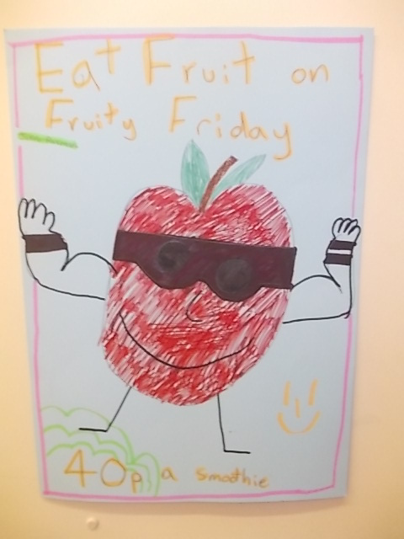  We had a Pupil Voice assembly last week led by the Pupil Action Group who delivered an interactive and entertaining assembly on friendship. Pupils acted out situations, shared a story, and presented a poem that the whole group had written. The Eco Action Group and Health Action Group shared what they had been doing with the rest of the school.  The Health Action Group organised a Fruity Friday smoothie day – thanks to the Green Grocer of Inverurie for supplying the fruit

Our vision for Oyne School is for happy achieving children …  World Book Day  P3/4 are organising fun activities for World Book Day on Thursday 3rd March. Pupils may come dressed as their favourite book character (no money required), they can bring books they no longer need for a book swap and they will have fun taking part in reading activities in class.  Coffee Afternoon  Thank you to all who attended our Coffee Afternoon. This year as well as our regular Fairtrade Stall we had a display about St Kizito. Pupils were able to share their Interdisciplinary Learning that they had done. These were topics that pupils were able to learn more deeply about and be able to apply their skills that they have developed through the broad curriculum.  Science  P5/6/7 enjoyed a science afternoon organised by Mrs Walker. They enjoyed different oactivities to investigate the carbon cycle.  Feedback  We always welcome feedback to help us do a good job. There is a question of the month at the end of the newsletter. Please return or email if possible. | Our vision for Oyne School is for happy achieving children…  Events  Our P6 and P7 pupils represented Oyne at the recent Rotary Schools Quiz in Inverurie  Oyne School partcipated in the Great Schools Birdwatch at the beginning of the month    The Eco Action Group are looking for old pairs of wellies! Please hand in any that you have to Mrs Taylor or Miss Mowat – holes don’t matter!

Diary Dates
Tues 1st Mar | Coffee Afternoon | 2.00pm onwards – all welcome
Thur 3rd Mar | World Book Day | Dress as your favourite character
Mon 7th Mar | K’nex workshops
Fri 18th Mar | Sport Relief Day | More info to come
Wed 23rd Mar | School Reports issued
Fri 25th Mar | Good Friday Holiday | No School
Wed 30th/Thu 31st Mar | Scholastic Book Fair
Wed 30th Mar | Parent Interviews | 3.30 – 5.00pm and 6.30 – 8.30pm
Mon 4th April – Fri 15th April | Spring Holidays
Mon 25th Apr – Fri 29th Apr | P6/7 residential trip to Dalguise
Mon 2nd May | May Day Holiday
Wed 4th May | Parent Council | 7.00pm – All welcome
Thu 2nd June | Sports Day | 2.00pm – all welcome
Mon 6th June | Occasional Holiday
Thur 30th June | End of Year Assembly | 2.00pm – all welcome
Fri 1st July | Last day of school year
Mon 15th Aug | In Service Day
Tuesday 16th Aug | First Day of new term | P1-7

After School Clubs

Netball – just a reminder that the netball after school club for p5-7 starts this Tuesday in the school hall – please let us know if your child will be attending and don’t forget to register your child on the Active Schools website so the club have all the necessary information for the register - http://www.aberdeenshire.gov.uk/leisure-sport-and-culture/active-schools/in-your-area/garioch/inverurie-primary-network/.

Jogging – the jogging club will restart after the Easter holidays. The first session will be Monday 25th April. Parent helpers would be appreciated – please complete and return the slip indicating which sessions you would be able to help with. To help runners prepare for Run Garioch on the 20th, Lesley is organising 2 sessions on Monday 14th for P1-3 and Friday 18th for P4-7 – both sessions will take place after school in the school field – weather permitting.

Scholastic Catalogues / World Book Day Tokens

The latest Scholastic catalogue is attached – or will be sent home with pupils for those receiving this electronically – if you wish to place an order please return to school by Friday 11th March. Also being sent home are the World Book Day Tokens, there’s one for each pupil and these can be used at participating booksellers – see the reverse for details of how to use these.

The Scholastic Book fair will be in school on Wednesday 30th March and parents will have the chance to browse when they’re here for the parent interviews that day.

Active Schools Easter Programme

Please also find attached the Easter Programme of activities being organised by Active Schools

Oyne 0-4 Group

This group meetings in the village hall on Mondays from 10-11 am – an opportunity to play, make friends and chat. Admission is £2. Contact Michelle at zerotofouroynegroup@outlook.com for more information.

Question of the month!
How effectively do we support parents and carers to participate in, contribute and understand their child’s learning?

-----------------------------------------------------------------------------------------------------------------------------------------------
Parent Consultation Evening – Wednesday, 30th March

Family Name _____________________________________

I would be able to attend (please tick as appropriate):

6.00-7.00 pm 

7.00-8.00 pm 

8.00-8.30 pm 

I would prefer an afternoon time (between 3.15 pm to 5.00 pm) 

I am unable to attend on 30th March. A suitable day for me is: _________________________

Signed: ____________________________________________

-----------------------------------------------------------------------------------------------------------------------------------------------

After School Jogging Term 4

Name ______________________________________________

I can help with jogging on the following dates:-

25 Apr |  | 9 May |  | 16 May |  | 23 May
30 May |  | 13 Jun |  | 20 Jun

Signed: ___________________________________________________

