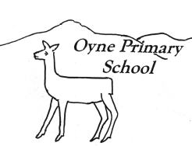
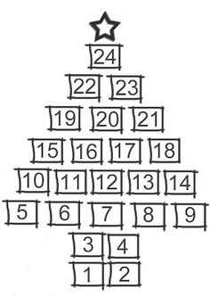

Newsletter No 5 – 1st December 2016

kindness…respect…tolerance…fairness…achievement…happiness…being included…being listened to…
Our vision for Oyne School is for happy achieving children to be supported to do their very best learning within a caring school and community.

Dear Parents and Carers,

This time of year always races by. We are full of Christmas songs and music already. I hope you enjoy our Christmas Celebration next week – it promises to be epic! Thanks to all who have returned the various audits regarding homework and new approaches to reporting. I will let you know in the new year what the outcomes of the the feedback will be.

You will see that pupils have had some great learning experiences during November. We have been using technology to ‘reach for the stars’ and looking to the future for our P7s and all those who come behind them. Along side all that we have been thinking about others in the past and in the present.

Regards
Sharon Huxtable
Headteacher

Our vision is for…very best learning  Inverurie Community Campus  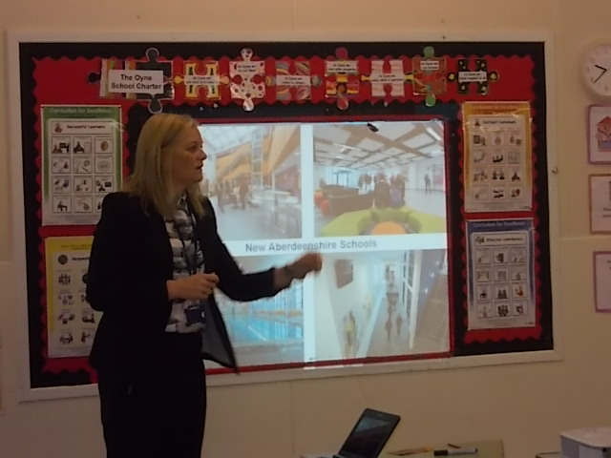  We welcomed Mrs Booth from the School Estates service who showed pupils what Inverurie Academy might look like when they get there. She was very impressed with the quality of our questions! | Our vision is for happy achieving children…  P7 Transition Music Day  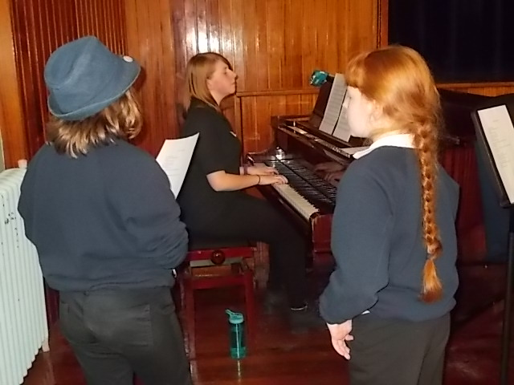  Primary 7 pupils were welcomed to Inverurie Academy for a Music Day. S6 pupils planned and led the day which started with performances from Celtacad and soloists from the academy. The rest of the day pupils worked in groups to prepare a song to perform to academy pupils at the end of the day. The P7s had great fun, learned a little bit more about what it’s like at the academy and were an asset to Oyne School.

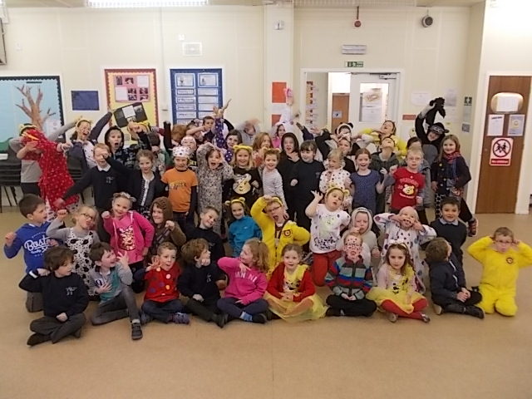
We value…kindness…being included
Children in Need
As usual we all had great fun on Children in Need day. Pupils were truly SPOTactular and enjoyed the fun activities in the afternoon. Of course it is all for a serious cause and we raised £297 to support children less fortunate than ourselves. Special mention for Meg Barnett who raised £78 by doing a sponsored silence for the day!


Our vision for Oyne School is for happy achieving children to be supported to do their very best learning within a caring school and community.

Christmas Reminders
- We are rehearsing madly for our Christmas Celebration on Tuesday 6th and Wednesday 7th Dec evening – pupils to be at the hall by 6.45 for a 7.00 start.
- We are holding our dress rehearsal at the hall at 10.00am on Tuesday 6th. As usual the Golden Oldies have been invited. If you know of anyone else who would prefer to come out during the day rather than at night please invite them along. We often get older folk and pre school pupils along and everyone is very welcome – no tickets required.
- Rev Dr Kay Gauld is visiting the school this week to look at the Christian Season of Advent with pupils.
- School Christmas dinner is on 8th December.
- Puppet Show for pupils is on Tuesday 13th December
- Friday 16th December is the Christmas Jumper Day. Pupils are invited to wear a Christmas jumper or something festive and make a donation to Save the Children.
- As usual we invite parents and pupils to send a single Christmas Card to the whole school rather than writing out lots of individual ones. Cards are shared with everyone at assembly. Please send any money saved into school and we will add it to the Save the Children donation.
- Pupils will enjoy a Christmas craft afternoon on Friday 16th December – many thanks to the PTA for funding sparkly resources
- Our Christmas party for the whole school will be at 2.00pm on Tuesday 20th December. Pupils should wear school uniform to school and will be able to get changed into party gear if they wish at lunch time.
- Wednesday 21st December - Last day of term - Whole School Film afternoon – popcorn and juice provided.

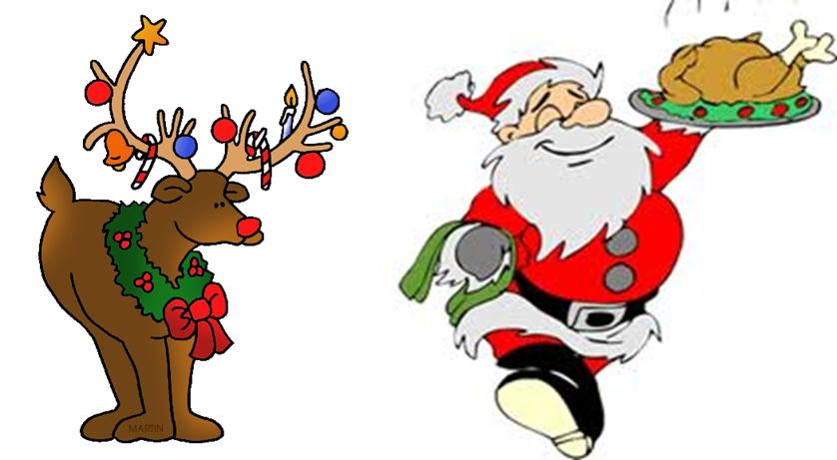
Christmas Lunch – Thursday 8th December

Menu – Roast Turkey and Skirlie (or Quorn and Gravy), Roast Potatoes, Carrots and Sweetcorn, Chipolata Sausage, Ice Cream and Fruit, Jelly. There are no alternatives or sandwiches on this day.

Party Lunch – Tuesday 20th December
Choice of sandwiches, crisps, little sausages, fruit, again this is the only option on this day.
Community News

A Christmas Carol Service will be held on Sunday 11th December at the Oyne Village Hall at 6pm . Refreshments will be served after the service. Please bring a candle.
All ages very welcome.

Parental Consultation

Please see attached the government information about assessment.

Also the government information about changes to school governance can be accessed on

http://www.gov.scot/Resource/0050/00509546.pdf

Our vision for Oyne School is … to do their very best learning …  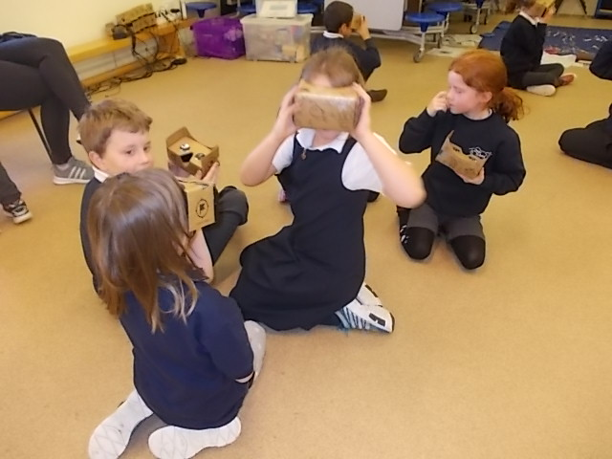  Google Expeditions  P3 – 7 pupils explored the galaxy with Google Expeditions. Lucy came with lots of virtual reality headsets and pupils were able to see the solar system, under the water, Rio de Janeiro and inside a volcano. | Story Telling  We welcomed Karen Hudsen into school to share stories from the Bennachie . Pupils listened to stories and created their own in a story circle. Pupils then made clay totems.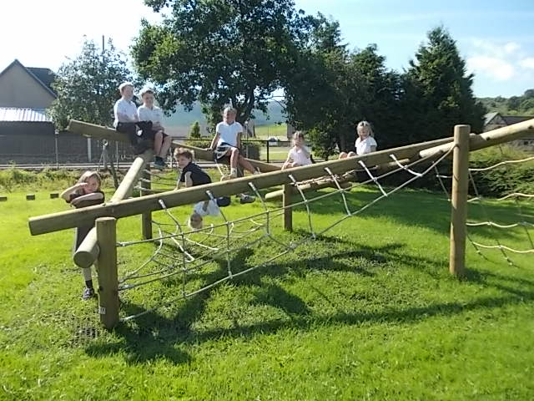
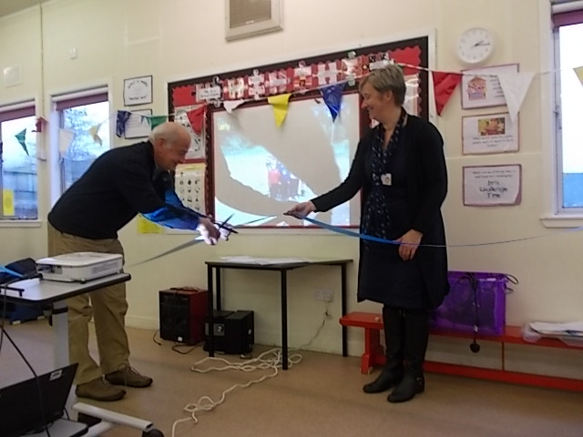
Opening Ceremony
We have enjoyed our new play equipment so much since it went in it was about time that we celebrated and thanked those who made it happen. We worked during the week with the help of Mrs Hassan to create a timeline for the school grounds and on Friday 4th November we invited all the parents and friends of Oyne School to share in our celebration. Pupils sang a song, shared the story of the playing field and created some lovely pictures to share. Many thanks to all who served teas and contributed lovely homebakes. It was wet outside but warm and dry in the hall we were grateful that Mr Savage could come and cut our ribbon to pronounce the play equipment officially open.
Remembrance
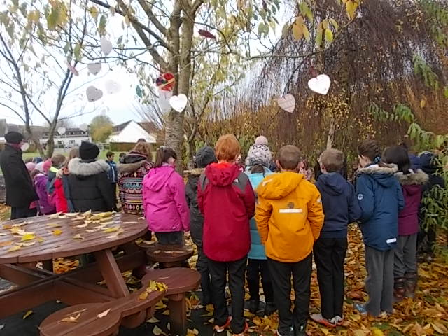
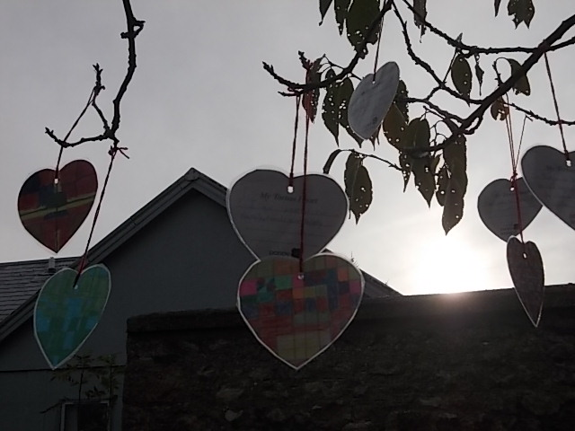
Mrs Taylor’s class led the school in their ceremony of remembrance. We all had hearts that we had to decorate and on the back to say somethinig that we are thankful for. Then everyone hung them in the trees before gathering for our minutes silence. It was very moving. Thanks to Willem for reading the poem.

School Diary Dates 2016-17

Date | Event | Times
Dress rehearsal Tues 6th Dec  Tuesday 6th and Wed 7th December | Golden Oldies, preschool invited  Christmas Performances | 10.00am  7.00pm – all welcome
Thu 22rd Dec – Wed 4th Jan (inclusive) | Christmas Holidays
Thurs 2nd Feb | Parent Council | 7.00pm – all welcome
Fri 10th Feb | Occasional Holiday
Mon 13th Feb | Spring Midterm holiday
Tues 14th and Wed 15th Feb | In Service Days 4 & 5
Tues 7th Mar | Open Afternoon Event | 2.00pm onwards – all welcome
Wed 22rd Mar | School Reports issued
Wed 29th Mar | Parent Interviews | 3.30 – 5.00pm and 6.30 – 8.30pm
Mon 3th April – Mon 17th April | Spring Holidays
Mon 1st May | May Day Holiday
Tue 30th May | Parent Council | 7.00pm – all welcome
Thu 1st June | Sports Day | 2.00pm – all welcome
Mon 5th June | Occasional Holiday
Thur 29th June | End of Year Assembly | 2.00pm – all welcome
Fri 30th June | Last day of school year
22nd August | First day of school for pupils
Any new dates are in bold
I include a ‘question of the month’ as part of our on-going self-evaluation routines. Please return in a pupil bag or by email.
Question of the month!
What makes our school unique?

December 2016

