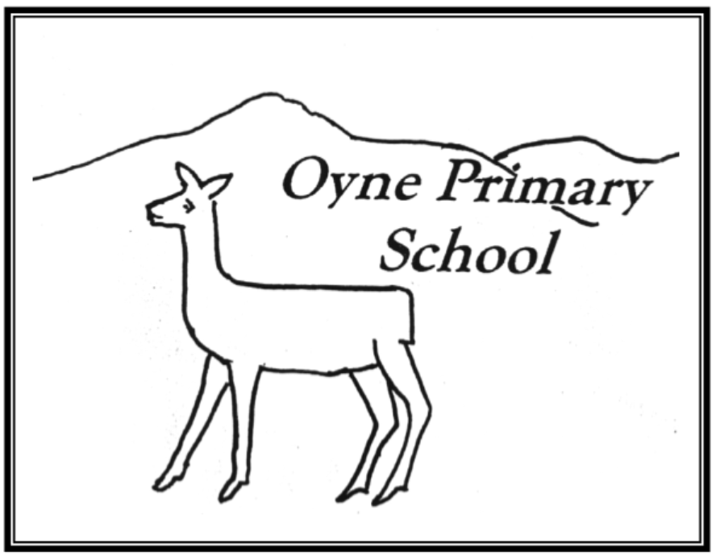

**Positive Relationship and Behaviour Policy**

Updated May 2019

**Better Relationships, Better Learning, Better Behaviour**

“Developing good relationships and positive behaviour in the classroom, playground and wider community is essential for creating the right environment for effective learning and teaching. Where children and young people feel included, respected, safe and secure and when their achievements and contributions are valued and celebrated, they are more likely to develop self-confidence, resilience and positive views about themselves.”

Scottish Government 2013



Dear Parent/Carer,

This policy outlines how Oyne School aims to:

* educate the whole child and develop their personal and social skills to ensure their own wellbeing and that of others
* provide safe and stimulating learning environments for all children and young people enabling them to reach their full potential and become successful learners, effective contributors, responsible citizens and confident individuals
* ensure children and young people have regular opportunities to develop an understanding of their rights and responsibilities
* develop an awareness of consequence in children and young people
* develop a desire in our pupils, families and staff to make a positive contribution to their community and wider world
* Recognise and develop positive qualities in themselves and others including leadership capacity and skills for life, learning and work

This policy has been developed in consultation with pupils, families and staff. As with all our practice, the successful implementation of the policy is dependent on a successful and supportive relationship with parents, carers and our pupils. This policy will be reviewed regularly and amended in response to feedback and consultation. This will ensure positive outcomes for all.

If you have any questions or comments regarding this document, please do not hesitate to get in touch.

Kind Regards,

Lindsey McBride

Head Teacher

Introduction

Oyne School is a wee school with a big heart and a family atmosphere. We are committed to fostering an ethos which promotes relationships built on mutual trust and respect. We work hard to create an engaging and empowering climate for learning which supports our vision.

All members of the school community ensure our values; kindness, respect and resilience, underpin our day to day conduct.

Relationships are central to positive behaviour. Across the school community relationships are positive and supportive and there is a strong sense of community, shared values and high expectations. Our nurturing and inclusive practice supports a restorative approach to building positive relationships and encouraging positive behaviour.

All staff understand and accept that the responsibility for promoting and developing positive relationships with children lies with them. and model high standards of behaviour. Through our conduct we demonstrate how we establish and maintain positive relationships and deal with challenging situations when they arise. Through supporting the development of emotional literacy through the ‘Emotion Works’ approach, relaxation techniques and mindfulness help our young people to manage and regulate their emotions and behaviours. Our restorative approach enables our pupils to develop their ability to reflect on challenges and mistakes and help them to move forward in a positive manner.

This policy is underpinned by the *United Nations Convention on the Rights of the* *Child* and wellbeing indicators – in line with *Getting It Right For Every Child*. All members of staff at Oyne School will reinforce and celebrate positive behaviour by modelling rights respecting behaviours, actions and language. There is an expectation that all members of the school community will also model these behaviours.

**The Role of School Staff:**

Relationships and communication between all adults and children should show respect, cooperation, tolerance, encouragement and praise. They should reflect the underlying principles of nurture and restorative practice.

Staff are responsible for:

* Promoting and upholding the Positive Relationship and Behaviour Policy;
* Supporting an ethos where children feel safe, secure and cared for where positive relationships are seen as fundamental;
* Establishing open, positive, supporting relationships across the community
* Engaging with partners such as Educational Psychologists and high quality CLPL in order to plan and deliver suitable interventions for children who have been identified as requiring additional support in the development and maintenance of positive relationships;
* Monitoring incidences of negative behaviour and supporting children, staff and families in resolving regular reoccurrences of these behaviours;
* Embedding the 6 nurture principles across all aspects of school life:
  1. Children’s learning is understood developmentally
  2. The classroom offers a safe base
  3. The importance of nurture in the development of wellbeing
  4. Language is a vital means of communication
  5. All behaviour is communication
  6. The importance of transition in children’s lives.



* Having high expectations of all children;
* Following restorative approaches to ensure a consistency and fairness
* Providing a rich, stimulating, varied and challenging curriculum and teaching methodologies which foster high levels of pupil engagement;
* Listening to children and all members of the school community;
* Being sensitive and responsive to the wellbeing of each child and young person

**The Role of Parent/Carer**

* To promote and uphold the Positive Relationships and Behaviour Policy;
* To respect the professionalism and experience of staff;
* To ensure school staff are aware of any additional needs or personal circumstances which may result in their child displaying behaviours which are not typical of them;
* To attend meetings with staff;
* To address issues to the class teacher in an appropriate and timely manner;
* Parents/carers are expected to discuss all concerns regarding their child/children with a member of staff and trust that the matter will be investigated, addressed and appropriate action taken. Parents/carers should not approach other children or adults.
* To work with the school to support their child’s positive behaviour.

**Getting It Right For Every Child**

While these are standard procedures for supporting children, each child is an **individual** and so each situation will be dealt with in a manner appropriate to the needs of the child and their family.

**Restorative Practice**

Restorative discussions are key as a positive behaviour strategy which help support children recognise the impact of their actions and identify ways to resolve conflict and/or make improved choices. Restorative discussions and approaches support pupils by helping them talk about their thoughts and feelings, take responsibility for their actions and develop skills in order to rebuild/repair relationships. These discussions often involve children affected by negative behaviours also, with staff supportively guiding dialogue and mediating.

**Questions we may ask during a restorative discussion are:**

**When things go wrong…**

1. What happened?

2. What were you thinking about at the time? What are you thinking now?

3. How do you think it made _______ (Name) feel?

4. How would you feel if it happened to you?

5. What do you think you need to do to repair the harm/to put things right?

**When someone has been harmed…**

1. What happened?

2. How did it make you feel? How are you feeling now?

3. What has been the hardest thing for you?

4. What do you think has to happen to make things right?

**Emotion Works**

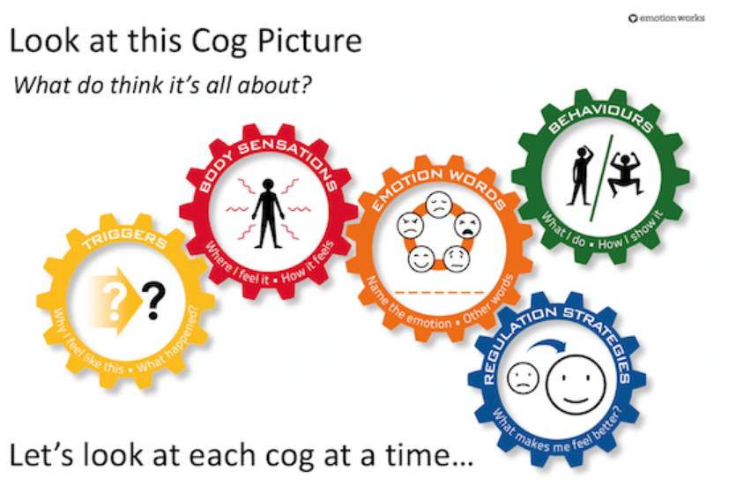

Our restorative approach is supported by an approach called ‘Emotion Works’. Emotion Works is an educational programme for emotional learning and literacy. Based around a visually supportive framework for learning and talking about emotions, the goal is to build emotional language and understanding in children and young people to help develop emotional competence and resilience.

The Emotion Works approach also provides tools to facilitate discussions around negative feelings, attitudes and behaviours.

**Encouraging, Recognising and Celebrating Positive Behaviour**

We utilise a vast range of strategies and methods which recognise and reward children for demonstrating our school values and associated attitudes and behaviours. These include, but are not limited to:

* Non-verbal rewards such as thumbs up or a smile;
* Praise;
* Celebrating work by sharing with others including parents (via SeeSaw);
* Stickers
* Awards such as ‘Star Writer’ etc
* ‘Building Block to Success’ Certificates – awarded at assembly;
* Notes/letters/emails to parents/carers;
* Celebrating achievement on social media and newsletters;
* Every child will have work displayed on the class ‘Wow Work’ displays;
* Displaying and highlighting out of school achievements on our Achievement Wall, newsletter, at assemblies and during ‘Shared Learning’ Reflection Time.
* Awarding House points and House Rewards
* Awarding ‘Class Punches’
* Class rewards when ten Punch Cards have been filled
* ‘Golden Moment’ Sticker
* Opportunities to adopt leadership roles and positions of responsibility such as running a lunchtime club, being a Play Leader or Literacy Coach.

**House Points**

House points are awarded for demonstrating our school values and can be awarded by any member of staff. A coloured token is given and placed into the appropriate House’s pocket (displayed on the wall). Children can earn Golden Tokens (worth 5 House points) by ‘going the extra mile’. House points are counted every two weeks and the winning House announced at assembly. The winning House receives the privilege of using ‘Golden Mats’ at lunchtime and other rewards.

Each term, the House with the highest points total earns a reward such as a workshop, arts and crafts activity, PE session, movie afternoon etc. The rewards are decided in consultation with the children and may change on a term by term basis.

**Punch Cards**

Each child has a ‘Punch Card’ on which they collect stamps. Again, stamps are awarded in recognition of displaying school values and positive behaviour. Once a child has filled their card by earning ten ‘punches’, they receive a reward and a Golden Token for their House. Every time ten Punch Cards have been filled, the whole class receive a reward. Again, the rewards are decided by the class and class teacher and will vary from class to class.

**Golden Moment Stickers**

As often as possible, ideally every day, classes will reflect on positive moments from their day. Anyone who has been identified as being part of someone’s ‘Golden Moment’ will be given a sticker and a House Point. This will help children recognise the positive contribution they make to the lives of others.

**Consequences**

The UNCRC states that “Discipline in schools should respect children’s human dignity” (Article 28). In order to protect the rights of our children, we believe it is important to build clear consequences for negative behaviours into this policy.

This policy has been created in consultation with all stakeholders. Therefore, with support, clear boundaries and a focus on celebrating positive behaviour, all members of the school community will have a clear understanding of what is expected and the consequences resulting from negative, undesirable or inappropriate behaviours.

The following system has been agreed:

**Stage 1 – Verbal Reminder**

The negative behaviour will be identified, stated and the pupil will be reminded of the school values.

**Stage 2 – Visual Reminder**

If the negative behaviour persists, the child will be issued with a ‘Stop and Reflect’ card which can be held by the pupil or placed on their desk.

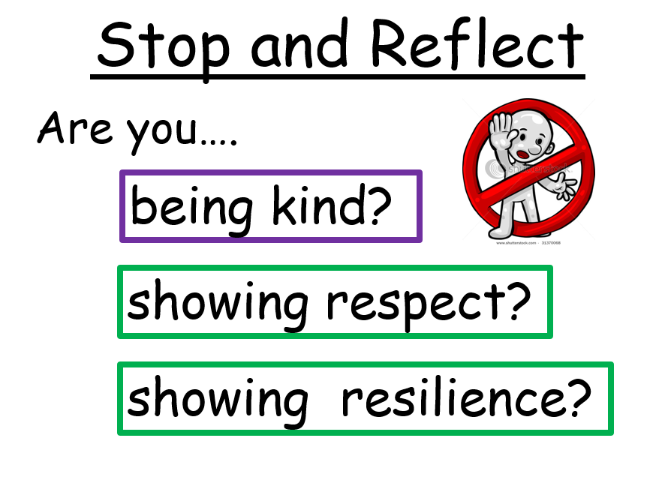

**Stage 3 – Visual Reminder sent to parent/carer via See-Saw**

A digital version of the Stop and Reflect card will be sent to the parent/carer of the pupil with an indication of which value was not being demonstrated by the child. Please note that if the behaviour persists that this will not be sent as the procedure will move directly to Stage 4.

**Stage 4 – Orange Slip Letter issued to parents/carers (see Appendix 1)**

The child will be issued with a letter home which gives details of the behaviour/s and any consequence already put in place eg loss of access to playground. Parents/carers are asked to discuss this with the child, sign the letter and return this to school. A record of this will be kept in school in order to help us identify patterns of behaviour and specific triggers and challenges. This will also facilitate reflection on behaviours and incidents and help identify appropriate supports and strategies.

**Stage 5 – Consultation Meeting**

If the strategies in place have not been successful in promoting positive behaviour, a consultation meeting will be held. The meeting will involve school staff, parents/ carers and, where appropriate, the pupil. The purpose of this meeting is to discuss any factors that may be impacting the pupil and to identify steps that can be taken to make a positive impact learning and behaviour.

**Specific Incidents**

Specific incidents eg reports of fighting, swearing etc will be investigated thoroughly to establish the facts of the incident as best we can. Once this has been done, pupils involved will be spoken to and appropriate action taken. This may include having a restorative conversation, completion of a ‘Think Sheet’, discussion with parent and/or one or more of the additional consequences listed below.

**Additional Consequences**

* Conversation with Head Teacher.
* Temporarily moving pupil from group within classroom
* ‘Time Out’
* Restorative measures such as writing a letter of apology
* Loss of access to playground during break/lunchtimes
* Loss of privileges eg access to football pitch, attendance at a club/activity
* Daily/weekly reports to parent/carer
* Target sheet

**Serious or Unexpected Behaviours**

In the unlikely event of a serious incident of display of negative behaviour the following procedures will be undertaken.

* A full investigation will be carried out.
* Parents/carers will be contacted and, where appropriate, a meeting arranged
* Details of the incident will be recorded in the appropriate manner and support/restorative measures put in place where necessary
* Appropriate consequences discussed and carried out
* Consequences may include:
* Internal exclusion (child withdrawn from class for a period of time)
* Extended period of exclusion from playground
* External exclusion (temporary exclusion from school)
* Permanent exclusion

**Exclusion: 2.1 Legal Context**

If all other interventions are evidenced as have been exhausted, exclusion may be an appropriate intervention to support learning and wellbeing with the aim of improving outcomes.

Under Regulation 4 and 4A of the Schools General (Scotland) Regulations 1975 (as amended), it is the education authority which has the power to exclude children from school. The Education (Scotland) Act 1980 places a duty on education authorities to make appropriate education provision when a child or young person is excluded. These powers (to exclude and make appropriate provision during exclusion) can be devolved by education authorities to senior management within a school. Regulation 4 and 4A provides that an education authority shall not exclude a child or young person from school unless the authority:

* “…is of the opinion that the parent/carer of the pupil refuses or fails to comply, or to allow the pupil to comply, with the rules, regulations, or disciplinary requirements of the school”; or
* “…considers that in all the circumstances to allow the pupil to continue his attendance at the school would be likely to be seriously detrimental to order and discipline in the school or the educational well-being of the pupils there.”

Excluding a child or young person for any other reason/purpose has no legal basis.

(Revised Management Circular No. 8, August 2018.).

Additional Considerations

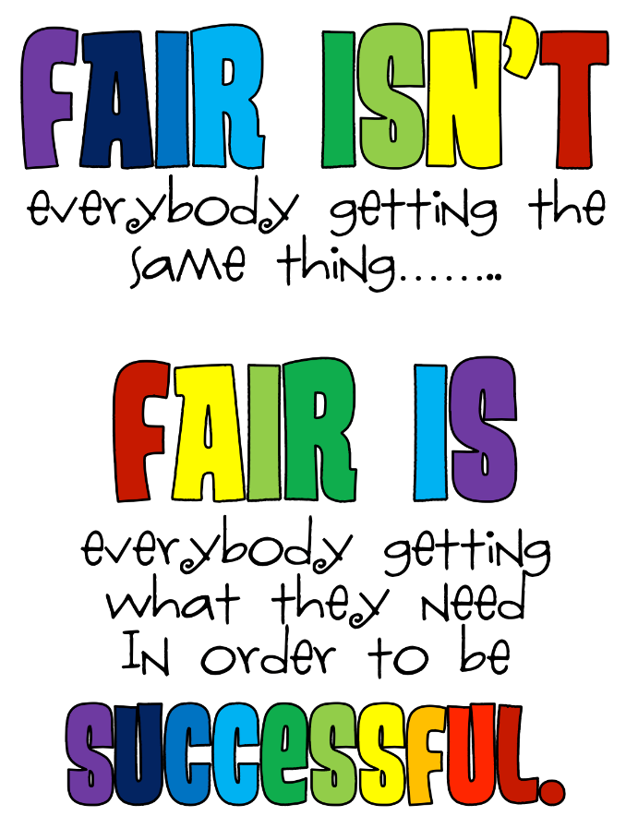

At Oyne School, each child is treated as an individual. There may be individual pupils for whom this system is not effective for a variety of reasons. It is important to understand that some children in school have additional support needs where their behaviour is affected by particular difficulties/challenges. These pupils may have very specific and tailored plans and strategies in place.

Bullying

Bullying in any form is intolerable and unacceptable. Parents/carers, pupils and teachers have a responsibility to work in partnership to maintain a high standard of behaviour and an environment free from bullying behaviour. Aberdeenshire Council believes that everyone should be treated equally and with respect.

Bullying takes place when the actions of an individual or group of people cause harm to someone by taking advantage of an imbalance of power within a relationship (whether perceived or real).

As per Aberdeenshire Council Guidance, Oyne School promotes consistency of response to instances of bullying behaviour using the 6 step approach:

1. Investigate and record the Incident
2. Speak to the individuals involved having frank and honest dialogue
3. Speak to parents
4. Utilise Restorative approaches and use Behaviour Policy procedures
5. Monitor the situation and support pupils involved
6. Review and increase response accordingly

Please refer to our Anti-Bullying policy for more information. This can be found at <http://oyne.aberdeenshire.sch.uk/>

Useful Policy Links

Anti-Bullying Policy for Learning Establishments (Aberdeenshire Council) <https://www.aberdeenshire.gov.uk/media/22025/anti-bullying-policy-2015-version-1.pdf>

Exclusion Policy (Aberdeenshire Council) <https://www.aberdeenshire.gov.uk/media/3901/policy_disc_exclusion.pdf>

Better Relationships, Better Learning, better Behaviour (Scottish Government) https://education.gov.scot/parentzone/Documents/BetterRelationships.pdf

Included, Engaged and Involved: A Positive Approach to Preventing and Managing School Exclusions (Scottish Government)

https://education.gov.scot/improvement/self-evaluation/Included,%20engaged%20and%20involved%20part%202:%20A%20positive%20approach%20to%20preventing%20and%20managing%20school%20exclusions%20(2017)

Getting in Right for Every Child (Scottish Government) https://www.gov.scot/policies/girfec/

Policy Review

Evaluation of this policy will focus on the impact on all members of the school community.

Impact may be measured through:

• Evidence and data

• Pupil discussions, feedback and experiences

• Gathering the opinions of staff members, parents and carers

This policy will be reviewed at least every 3 years.

Appendix 1 (printed on yellow paper)

 

Date: _______________________

Dear Parent/Carer,

We write to inform you that today __________________reached Stage 4 of our whole school Behaviour System.

The reason/s include (brief summary):

|  |
| --- |
|  |

We would appreciate if you would discuss your child’s behaviour with them at home and reinforce the school values – kindness, respect and resilience. You may also want to use the restorative questions that staff use with pupils. These can include:

1. What happened?

2. What were you thinking about at the time?

3. How did you think xx felt?

4. How would you feel if…..?

5. How can we put this right now?

Please sign and return the letter to school to acknowledge you have received it and discussed the incident/s with your child.

Thank you for your support.

Yours sincerely,

(Staff signature)

* I received a letter today informing me of my child’s behaviour in school and we have discussed this at home.

Parent/Carer signature __________________________ Date ____________