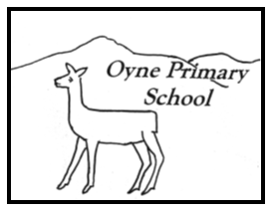
Our Vision
Oyne School is a happy place where everyone feels that they belong and that they matter. We work in partnership to support our children in becoming kind, responsible and successful citizens of 21st Century Scotland with a love of learning, respect for themselves and others and the confidence to change their world.
Values
Kindness Respect Resilience
Aims
- To teach you the things you need to know, the things you want to know and things that matter to you, your family and your community.
- To nurture and develop your skills and talents and will encourage you to share these with others. We will have high expectations and value your individuality.
- To celebrate success, praise effort and recognise achievements. We will value mistakes and encourage you to recognise these as part of your learning.
- To work together to provide you with interesting and fun learning experiences which inspire and excite you and help you to develop the skills, knowledge and qualities needed to succeed, thrive and be happy.
- You will be listened to. Your thoughts and opinions are important and will help to bring about school improvement and we will listen and support you through good times and bad.
- To work in partnership with our families and other agencies to enable everyone to play an active role making our school the best it can be.

