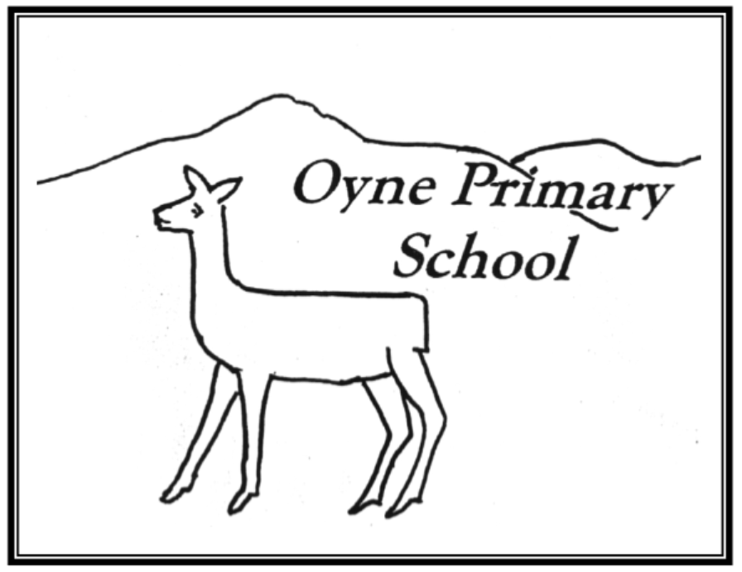
How good is OUR school?
“Oyne Schools works hard to take care of the planet.” – December 2019
Agree | Disagree
- “We are trying but we could try harder”  - We recycle lots of paper and cardboard, stationery and batteries  - Rag bag collection is well used  - We have Eco Champions  - Use milk bottles in staff room  - Children do litter picking  - Most children walk to school  - We have bug hotel and grow some food | - Could grow more in our outdoor space  - Use plastic toys as rewards and prizes  - Could we recycle crisp packets?  - Sometimes waste energy and water  - Some people drop litter

ACTIONS
- Eco Champions to do campaign for conserving energy, water and encouraging people to put litter in the bin
- Consider ways for reducing plastic waste eg use tokens for rewards instead of plastic prizes

