Oyne Parent Council Newsletter – September 19
Welcome to our Oyne Parent Council newsletter! We thought it would be good to issue you with some explanation about who we are and what we do and also let you know about our targets with regards to fundraising and some events we have planned. We hope to provide small updates for the school newsletter in the future.
Parent Council Role:
- Provide parents with a voice in the school community and an opportunity to discuss current issues affecting our youngsters
- Collating and representing views of parents more formally to the School or Local Authority
- Supporting learning and teaching within and beyond the curriculum by augmenting the school’s resources and influencing financial choices
- Creating and supporting a calendar of social and fundraising events to facilitate this and which help foster positive relationships in the broader school community
Who are Oyne Parent Council?
Current Committee
Chair: Murdette Price-Davies
Treasurer: Lieneke Van Beijma
Secretary: Moragh Boyle
Events: Denise Dey
Other parents and community members also hold voting rights but non committee positions and in addition many parents attend the meetings. You are all part of the Parent Forum if your child attends Oyne School and it is you we wish to represent.
Both Murdette and Moragh have held their roles for a little while now and both wish to step down. It is very rewarding being part of Oyne Parent Council and genuinely not very time consuming at all so please contact any committee member or the school if you wish to take on either role or become involved in any way.
Oyne Parent Council Events
The fundraising arm of the Parent Council organise and put on various events and activities with a view to having some fun at social occasions but also raise vital extra funds for the school. In the recent past money has been raised for :-
- Provision, development and maintenance of additional play equipment in the school field
- A full class set of iPads and charging trolley;
- Accelerated Reader programme for all year groups;
- Early years class readers;
- Library furniture and books;
- School trips including annual school trips to TechFest and Absafe and occasional trips such as to the theatre.
Right now we also have funds ring fenced for the purchase of 4 new laptops.
Outdoor Classroom Fundraising
At our last Parent Council Meeting we discussed and agreed to target fundraising for provision of an outdoor classroom area, such as per the images below.
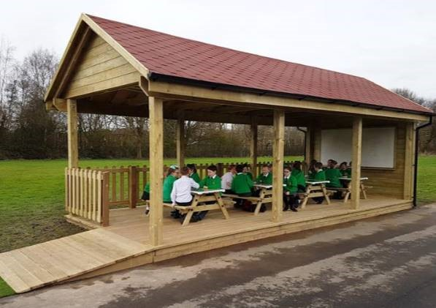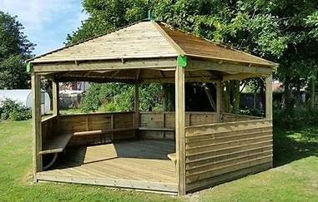
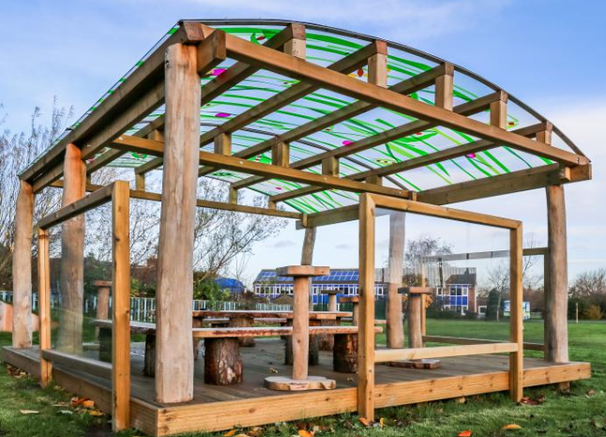
As you can imagine this is a sizeable undertaking and we believe funds in the region of £8000 will be required. However, the idea of having an outdoor classroom space for the use of the children of Oyne School for many, many years to come would be fantastic and we think will be well worth the effort.
Upcoming Events, Activities and requests (See Oyne Parent Council Events Page on Facebook, please like and share the page)
Library – an ongoing request for old soft furnishings (cushions, bean bags, blankets or throws) and we will always welcome donations of old books suitable for the children.
Aldi Stickers – another ongoing request - This year Oyne School will be taking part in Aldi's Kit for Schools promotion. The promotion will run from 6th September until 3rd November and anyone who spends £30 in an Aldi store will receive a Team GB athlete sticker. We will be collecting the stickers in school and if we are able to collect 300 stickers the school will receive a sports kit and an entry into a draw to win £20,000 for the school.
If you manage to collect any if you could post them in the school letterbox at the school entrance it would be greatly appreciated.
Anyone can collect stickers so please ask friends and family too!

Saturday 5th October 2019
12.30pm – Oyne School Field Tidy
At our recent meeting it was highlighted that our school field / garden is in need of some tlc and in particular the willow tunnel. We are looking for some volunteers to meet at the school playing field on Saturday 5th October from 1230hrs to assist with some gardening work. Currently we have some trailers organised, however feel free to bring along some tools, in particular, telescopic loppers, ladders, petrol hedge trimmers, sledge hammers (the gazebo needs to be dismantled) and anything else that you think would assist.
Children are welcome to come and play in the field whilst parents help, however should obviously stay clear of any machinery.
Hopefully it will help build an appetite for the chipper night that evening 😉
Fish and Chips Night 6pm, Oyne Village Hall
Reminder tickets must be purchased prior to this event & donations of desserts is appreciated
We are also running a Lucky 100 square – squares are £2 and can be purchased via paypal, details on the Parent Council Events page.
Friday 1st November 2019
Halloween Party - parent helpers will be required along with party food donations. Further details will follow on our facebook events page.
Christmas Cards
Christmas card templates have been returned to the manufacturer and the samples will be distributed to the children soon with order forms. More details will follow.

