How good is OUR school?
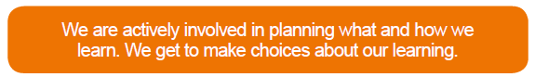
“School staff, our friends and our families support us mentally and emotionally. I know what I can do to help myself and others improve their mental health.” – January 2020
Agree | Disagree
- Children are becoming more confident in the use of mindfulness techniques which help them in some circumstances (Paws B)  - Most children enjoy the health and wellbeing elements of activities such as drumming and juggling.  - Tapping is useful to some children.  - Most children were able to identify strategies that help them regulate their emotions such as taking time out, distractions, scaling, emotion works (identifying triggers).  - Most children were confident in discussing ways they can help their friends and understood the importance of talking to someone.  - Some children commented that getting to know staff well helped their mental health. | - Some children do not enjoy whole class mindfulness activities as they feel a bit awkward  - Siblings can sometimes be a trigger for anger or anxiety  - Some children wanted more practise in Paws B techniques (particularly P1-4)  - Some children felt that life was ‘just difficult’.
ACTIONS
- Establish Health and Wellbeing club/ambassadors – this may include establishing worry boxes around the school
- Paws B sessions for younger classes led by Gillian and Wellbeing Ambassadors
- Establish daily 5 minutes of mindfulness/relaxation
- Continue to focus on developing growth mindset

