**Aberdeenshire**

**Skills for Learning, Life and Work Guidance**

**INTERIM December 2015**



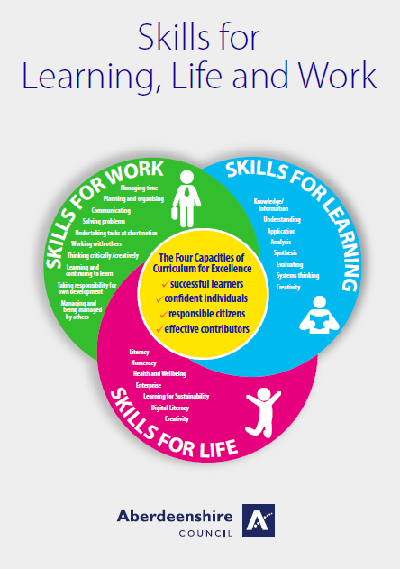

**An Aberdeenshire Skills for Learning, Life and Work Poster has been created to**

* provide a readily accessible reference point for educators and pupils to relate learning activities to a common vocabulary of skills for learning, life and work

* emphasise the inter-related, complementary and overlapping nature of skills for learning, life and work.

**CONTENTS**

**SECTION 1 – SETTING THE CONTEXT**

* **Introduction**
* **Building the Curriculum 4**
* **Skills for Learning, Life and Work and four capacities**
* **Developing the Young Workforce**

**SECTION 2 – DEFINING SKILLS FOR LEARNING, LIFE AND WORK**

* **What is a skill?**
* **Core Skills**
* **The Learning Environment**
* **What are the Skills for Learning, Life and Work?**
* **Skills for Learning**
* **Skills for Life**
* **Skills for Work**

**SECTION 3 – PLANNING AND ASSESSMENT**

* **Planning for skills for learning, life and work**
* **Assessing and reporting**

**SECTION 4 - APPENDICES**

* **Appendix 1- Skills for learning planning tool**
* **Appendix 2 - Skills for learning, life and work exemplification**
* **Appendix 3 - Skills for life and work planning tool**
* **Appendix 4 – Planning for skills**

**Acknowledgement**

Aberdeenshire Council’s Framework for Skills for Learning, Life and Work is informed by the work of Aberdeenshire schools, Angus Council, Argyll and Bute Council, Dundee Council, Highland Council, Perth and Kinross Council, Education Scotland, and Skills Development Scotland. It has also been informed by the revised Blooms taxonomy (2001)[1] and Blooms Cognitive taxonomy (2011)[2]

**SECTION 1 – SETTING THE CONTEXT**

**Introduction**

Our education system is preparing young people for a world where change and innovation is constant. Many young people, when they enter the world of work, will have multiple jobs and may change career more than once. In this context, knowledge can very quickly become outdated and irrelevant.

Skills for learning, life and work, however, provide the means by which learners can learn in a variety of contexts and transfer and apply that learning elsewhere. Learning how to articulate and evidence their own developing skills will become increasingly valuable for young people as they move towards the workplace.

“The key message, however, is that knowledge on its own is not enough. The task now is to create a curriculum in which the knowledge and skills are seen as mutually supportive and equally significant.”

Keir Bloomer, Chair Higher Order Skills Excellence Group

March 2011

**Building the Curriculum 4**

Building the Curriculum 4[3], published in 2009, sets out how skills for learning, life and work are embedded in Curriculum for Excellence, supports thinking about the development of learners’ skills from ages 3 to 18 across the curriculum, and underpins the work required to develop the young workforce, as described in *Education Working For All*, the report of the Wood Commission[4], and in the Scottish Government’s response, *Developing the Young Workforce.[5]*

**Key messages from Building the Curriculum 4**

1. The development of skills is essential to learning and education to help young people to become successful learners, confident individuals, responsible citizens and effective contributors.
2. All children and young people are entitled to opportunities for

developing skills for learning and life **from the early years right through to the senior phase of learning and beyond.**

1. There is a need to establish a common understanding and commonlanguage around skills development between pupils, parents, school staff and other partners.
2. Skills should be developed within and across the curriculum. (Their progression is “signposted” in the Experiences and Outcomes.)
3. Development of skills for learning, life and work should occur in a variety of contexts, including IDL, and in a range of different ways appropriate to learners’ needs. Partnership working adds value and relevance to this work.
4. The assessment process should help children and young people

* to understand why skills are important
* reflect on how they are developing their skills
* identify the next steps in their skills development
* increase understanding of the wider application of skills in their lives in and outside the classroom or establishment.

**Skills for Learning, Life and Work and the four capacities**

*Building the Curriculum 3: a framework for learning and teaching[6]* it states that the “*purpose of the new curriculum as being to enable the child or young person to develop the ‘four capacities’*”. There is strong and intentional overlap between the language of skills for learning, life and work and the descriptors for the four capacities as shown below.

**The purpose of the curriculum: the four capacities**

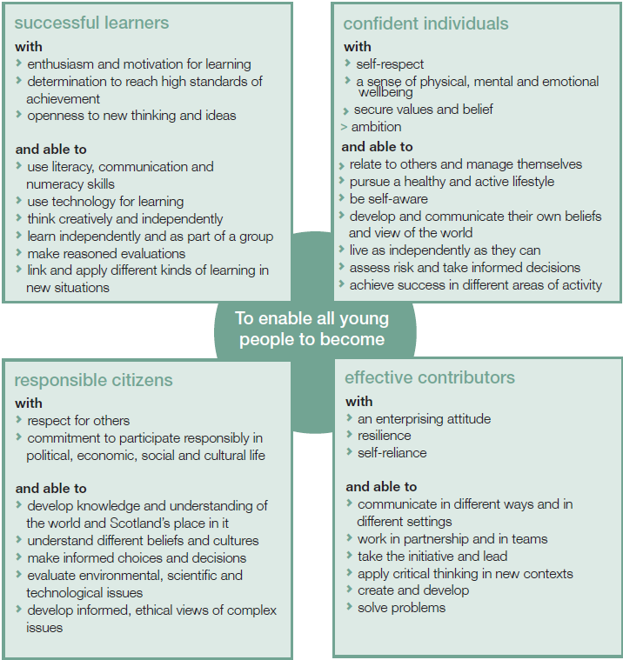

The place of Skills for Learning, Life and Work is also made clear within the schematic diagram in Building the Curriculum 3[7]

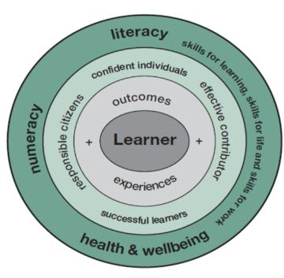

**Developing the Young Workforce**

*Developing the Young Workforce* sets out the Scottish Government’splans to be one of the top five performing countries in the EU for youth employment. The report recognises that ensuring young people are ready for work requires action to be taken at every stage of education, from 3-18 – and beyond.

This involves ensuring that young people have opportunities throughout their education to develop skills for learning, life and work and that work-related learning is a **part of each child’s curriculum at every stage from 3-18 and beyond.**

**SECTION 2 - DEFINING SKILLS FOR LEARNING, LIFE AND WORK**

**What is a skill?**

There are various definitions of 'skills'. Broadly, a skill might be usefully defined as

***an activity that a learner undertakes, can do again, can apply to different circumstances and can improve over time.[8]***

**Core Skills**

Underpinning all learning are six core cognitive skills. These have been proven to allow learners to take on knowledge, work with knowledge and create unique thought.

These Core skills are defined as:

* *Attention* **-** Incorporating the ability to regulate, move and sustain attention
* *Memory* **-** A vast skill including short term, long term and working memory. This skill includes visual, auditory and kinaesthetic domains
* *Language and communication* **-** Being able to understand and express through the use of funtional language using correct language structures
* *Perception* **-** Being able to gather information through all domains and understand how things relate to each other in the world *Reasoning and Logic* **-** The skills of systematically comparing, classifying and grouping, being able to understand one change when other things stay the same, understanding cause and effect and the skill of using anology and inference
* *Strategic thinking/metacognition* **-** The ability to understand what to do and what is relevant , creating and testing hypothesis and being able to plan systematically. It is also understanding the need for precision and accuracy and being able to think flexibility and understanding how to transfer and generalise concepts learnt and being able to evaluate oneself

**The Learning Environment**

The learning environment created by educators is key to fostering these essential learning behaviours.

* Being able to accept help from both adults and peers
* Being able to regulate emotions
* Being encouraged to be motivated and curious in response to challenge
* Having the confidence to persevere to develop in learning

**What are Skills for Learning, Life and Work?**

The set of Aberdeenshire skills has been identified to promote a shared understanding and language around skills for learning, life and work within and across schools and the wider community. These draw directly from guidance within Building the Curriculum 4 and information from Education Scotland.

**Skills for Learning**

Embedded within the Experiences and Outcomes of each of the Curricular Areas are the key thinking skills young people need to develop. These skills are revisited as skills need to be practised as pupils progress and develop.

A taxonomy is a classification of skills. It helps to organise thinking about skills development and provides a common language for discussion. Many teachers may, therefore, find a taxonomy useful in bringing to mind the different kinds of skill they are seeking to promote. There are a number of taxonomies which can be used as a starting point to help plan learning opportunities where skills are developed. These include revised Blooms Revised Taxonomy[9] , Blooms Cognitive Taxonomy[10] and SOLO[11]. The Taxonomy listed below is based on Blooms Cognitive Taxonomy[12] and is the basis of skills embedded in the Experiences and Outcomes.

**Skills for Learning**

* **Knowledge/ Information\***
* **Understanding\***
* **Application**
* **Analysis**
* **Synthesis**
* **Evaluating**
* **Systems thinking**
* **Creativity**

The first two items* may be considered as prerequisites of skills development.

The taxonomy is summarised in the diagram below. The diagram should also serve as a reminder that **skills for learning are not hierarchial: these skills can be developed at any stage in a learner’s education.**

**Skills for Learning**

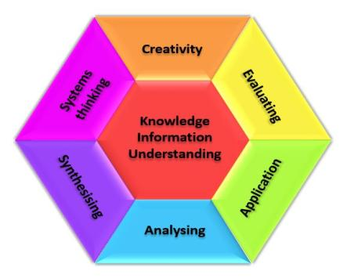

**Skills for Life**

Skills for life should be developed from the child’s earliest years and throughout their education as they are essential for all in our world of rapid change, mobility and diversity. Educators should look closely at their pedagogy to ensure they are providing varied opportunities to develop these vital skills.

The cross cutting themes of Curriculum for Excellence that are the responsibility for all are Literacy, Numeracy and Health and Wellbeing. In Aberdeenshire we have also identified Learning for sustainability, Enterprise, Creativity and Digital Literacy as cross cutting themes.

**Skills for Life**

* **Literacy**
* **Numeracy**
* **Health and Wellbeing**
* **Enterprise**
* **Learning for sustainability**
* **Digital Literacy**
* **Creativity**

**Literacy, Numeracy and Health and Wellbeing**

The ***Aberdeenshire Progression Frameworks for Literacy and* *English, Numeracy*** *and* ***Health and Wellbeing***set out a clear progression for knowledge and understanding and related skills, from the Curriculum for Excellence and associated significant aspects of learning. The progression frameworks set out a continuum of learning through CfE Early Level to the end of the Broad General Education (Third/Fourth Levels). They are intended to assist teachers in their learning and teaching approaches as they plan curriculum and assess evidence of learning including skills.

**Learning for Sustainability**

The term ‘learning for sustainability’ may be relatively new but the substance of what it represents will be very familiar.

It encompasses

* [global citizenship](http://www.educationscotland.gov.uk/learningandteaching/learningacrossthecurriculum/themesacrosslearning/globalcitizenship/index.asp)
* [outdoor learning](http://www.educationscotland.gov.uk/learningandteaching/approaches/outdoorlearning/index.asp)
* [children’s rights](http://www.educationscotland.gov.uk/resources/r/childrensrightsresource.asp?strReferringChannel=learningandteaching&strReferringPageID=tcm:4-844862-64&class=l4+d217876)
* [sustainable development education](http://www.educationscotland.gov.uk/learningandteaching/learningacrossthecurriculum/themesacrosslearning/globalcitizenship/sustainabledevelopment/introduction.asp)
* [international education](http://www.educationscotland.gov.uk/learningandteaching/learningacrossthecurriculum/themesacrosslearning/globalcitizenship/internationaleducation/index.asp)
* [education for citizenship](http://www.educationscotland.gov.uk/learningandteaching/learningacrossthecurriculum/themesacrosslearning/globalcitizenship/educationforcitizenship/index.asp)

Learning for sustainability enables young people to build the values, attitudes, knowledge, skills and confidence needed to develop practices, and take decisions, which are compatible with a sustainable and equitable society. It provides a context across learning for practitioners to plan for and develop skills for life in their young people and can be a rich context for inter-disciplinary learning. The values and principles of learning for sustainability are now embedded within the new GTCS Professional Standards for all registered teachers.

Further information about learning for sustainability can be found in both Education Scotland and GTCS websites. See the resources section for support documentation which exemplifies what these skills might look like in a Learning for Sustainability context.

**Digital literacy**

Digital literacyencompasses the capabilities required for living, learning and

working in a digital society. It includes the skills, knowledge, capabilities and

attributes around the use of digital technology which enable individuals to develop

to their full potential in relation to learning, life and work.

It encompasses the skills to use technology to engage in learning through managing information, communicating and collaborating, problem-solving and being creative, and the

appropriate and responsible use of technology. The *Aberdeenshire Technologies Framework* should be used by teachers and managers to plan for and assess all aspects of digital literacy including skills. Refer to the appendices for further exemplification.

**Enterprise**

Enterprise in education has always been about developing skills for learning, life and work in real life and meaningful context. Thinking about the use of skills in aspects of our lives helps learners to see the relevance of the skills and the way that they are applied in life and work for different purposes. This helps to motivate learners and shows the rich opportunities for developing skills across the [totality of the curriculum](http://www.educationscotland.gov.uk/learningandteaching/thecurriculum/whatiscurriculumforexcellence/understandingthecurriculumasawhole/index.asp).

Enterprise in Education encompasses

* an approach to learning, and
* a context for learning e.g. entrepreneurial learning

Effective enterprising teaching and learning should:

* allow learners to take responsibility and ownership for their learning
* provide opportunities for real life experiences, both in and outwith the classroom
* provide opportunities for learners to develop skills such as problem solving, decision making and evaluating risks
* use learning from different subjects and disciplines to explore a theme, issue, meet a challenge or solve a problem
* be one way of delivering an IDL project
* be collaborative in nature
* involve local community and local businesses where possible
* link very closely to skills for work.

See Appendices for exemplification of what these skills might look like in an enterprise context.

**Creativity**

Creativity is a process which generates ideas that have value to the individual. It involves looking at familiar things with a fresh eye, examining problems with an open mind, making connections, learning from mistakes and using imagination to explore new possibilities.[13]

The development of creativity skills should enable children and young people to become increasingly:

* motivated and ambitious for change for the better, including in their own capabilities
* confident in the validity of their own viewpoint
* able to apply a creative process to other situations
* and able to lead and work well with others, where appropriate.

The application of creativity skills as children and young people grow and develop skills for learning, life and work is particularly important. Creativity skills help children and young people not just to understand their world, but be sufficiently equipped to influence its shape and to exercise control over their interactions with it.

Further exemplification of what creativity could look like can be found in the appendix section of this document.

**Skills for Work**

Skills for Work can be developed across the curriculum and in all curricular areas. These are the ten softer skills that employers have suggested are vital for the success of their organisation. They can be found in Scottish Government’s lifelong skills strategy[14] and are defined as:

**Skills for Work**

* **managing time**
* **planning and organising**
* **communicating( oral and written)**
* **solving problems**
* **undertaking tasks at short notice,**
* **working with others**
* **thinking critically and creatively**
* **learning and continuing to learn**
* **taking responsibility for own development**
* **managing and being managed by others**

Making the link between the classroom and workplace can help young people to see the relevance of their learning and understand the contribution that they can make to their community and to the economy. Skills for work are important for all young people from 3-18as they apply to any career and are therefore transferrable. Learning about the world of work throughout their educational journey will allow young people to make informed career choices in an ever-changing career marketplace.

As a direct consequence of the implementation plan for Developing the Young Workforce published in December 2014, learners from 3-18 should be provided with relevant career education and education about the world of work. A suite of resources has been created by Education Scotland to facilitate this:

**Career Education Standard[15]**

The career education sets out what children and young people will learn and what parents, teachers, employers and Skills Development Scotland will do to support their learning. Implementation of the standard will improve the quality and consistency of learning about work and careers. The “I can” statements in the Career Education Standard (3-18) provide a basis for planning progress for children and young people on their journeys. This document can be printed from the Education Scotland website or accessed through the following ULR.

<https://www.educationscotland.gov.uk/Images/CareerEducationStandard0915_tcm4-869208.pdf>

**School Employer Partnerships[16]**

Involving employers and third sector providers in the school curriculum will enable pupils to see the relevance of their learning in a real life context and will enhance the development of the wider skills and knowledge young people need to flourish in life. Guidance on School Employer Partnerships published in Autumn 2015 supports the aim of having meaningful and productive school employer partnerships operating in all secondary schools by 2018/19.  This document can be printed from the Education Scotland website and can be accessed through the ULR below. Local document

<http://www.educationscotland.gov.uk/Images/GuidanceforEmployers0915_tcm4-871657.pdf>

**Standard for Work Placement[17]**

Secondary schools should use the new standard for Work Placements to inform the use of work placements in schools. More information can be found in the resource section of this do This document can be printed from the Education Scotland website and can be accessed through the ULR below.

<https://www.educationscotland.gov.uk/Images/WorkPlacementStandard0915_tcm4-870517.pdflow>.

Refer to appendices for a planning tool which indicates the links between skills for life and work.

**SECTION 3 -PLANNING AND ASSESSMENT**

**Planning Skills Development**

Skills for learning, life and work are embedded in the Experiences and Outcomes and their progression is signposted across the significant aspects of learning in each curricular area.

However, the fact that the skills are embedded does not abdicate responsibility to plan their systematic and progressive development in a manageable way. Involving young people in planning for skills development also helps them develop a shared understanding of the language of skills.

Planning for skills development should:

* Be developed and practised within and across the curriculum
* Use the Aberdeenshire Skills for Learning, Life and Work overview to identify an appropriate skills focus which inform medium and short term planning
* Be informed by the need to provide appropriate challenge through Skills for Learning
* Take account of prior learning for all learners
* Allow for skills to be developed within a context (see planning illustrations in support documentation)
* Allow for learners to have a clear understanding of the skills they are developing and why
* Provide opportunities for self-assessment in skills progression
* Help learners understand how skills can be transferred to other aspects of their learning within and beyond school.

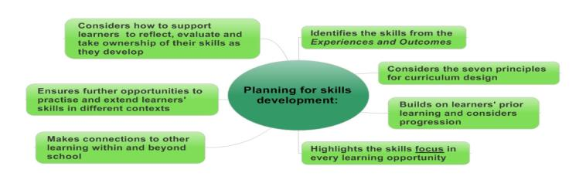

Further guidance and support in planning for skills can be found in the Aberdeenshire’s*Learning, Teaching and Assessment: Professional Curriculum Tool,* and in the support documentation accompanying this document.

**Assessing and reporting**

Assessment of skills is integral to the learning experience, not additional. It is not anticipated that additional assessment tasks specific to skills for learning, life and work should be developed where teachers and schools already use a broad range of approaches that assessof what pupils write, say, make and do.

Breadth, challenge and application are fundamental to planning learning activities that generate valid and reliable evidence for the assessment of pupils’ progress and achievement. Consideration needs to be given to:

* the range of skills to be assessed
* how well the skills are used in familiar contexts
* how well the skills are used in different contexts

Skills identified for assessment within a medium term planning period must be focused enough to allow retention of evidence which will exemplify progression in a manageable way. The identification of evidence will support and define next steps in learning.

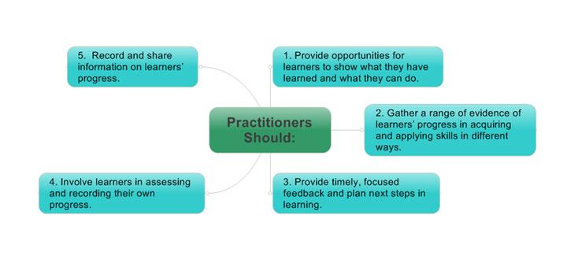

**SECTION 4 - RESOURCES**

**Appendix 1 – Skills for Learning Planning Tool**

This document should provide further exemplification of questions to consider, actions and products for skills for learning.

|  |  |  |  |  |  |
| --- | --- | --- | --- | --- | --- |
| **Skill for learning** | **Questions to consider when planning Learning activities.** | | **Actions** | **Products** | **Learning Activities** |
| **Creating**  (Putting together ideas or elements to develop an original idea or engage in creative thinking). | * Can you design a ... to ...? * Why not compose a song about...? * Can you see a possible solution to...? * If you had access to all resources how would you deal with...? * Why don't you devise your own way to deal with...? | * What would happen if...? * How many ways can you...? * Can you create new and unusual uses for...? * Can you write a new recipe for a tasty dish? | Designing  Constructing  Planning  Producing  Inventing  Devising  Making | Film  Story  Project  Plan  New game  Song  Media product  Advertisement  Painting |  |
| **Evaluating**  (Judging the value of ideas, materials and methods by developing and applying standards and criteria). | * Is there a better solution to...? * Judge the value of... * Can you defend your position about...? * Do you think ... is a good or a bad thing? * How would you have handled...? | * What changes to ...would you recommend? * Do you believe…? * Are you a ... person? * How would you feel if...? * How effective are...? * What do you think about...? | Checking  Hypothesising  Critiquing  Experimenting  Judging  Testing  Detecting  Monitoring | Debate  Panel  Report  Evaluation  Investigation  Verdict  Conclusion  Persuasive speech |  |
| **Analysing**  (Breaking information down into its component elements). | * Which events could have * happened...? * If ... happened, what might the ending have been? * How was this similar to...? * What was the underlying theme of...? * What do you see as other possible outcomes? * Why did ... changes occur? * Can you compare your ...with that presented in...? | * Can you explain what must have happened when...? * How is ... similar to...? * What are some of the problems of...? * Can you distinguish * between...? * What were some of the * motives behind...? * What was the turning * point in the game? * What was the problem with...? | Comparing  Organising  Deconstructing  Attributing  Outlining  Structuring  Integrating | Survey  Database  Mobile  Abstract  Report  Graph  Spreadsheet  Checklist  Chart  Outline |  |

|  |  |  |  |  |  |
| --- | --- | --- | --- | --- | --- |
| **Skill for Learning** | **Questions to consider when planning learning activiities** |  | **Actions** | **Products** | **Learning Activities** |
| **Understanding**  (Understanding of given information). | * Can you write in your * own words...? * Can you write a brief * outline...? * What do you think could have happened next...? * Who do you think...? * What was the main idea...? * Who was the key character...? | * Can you distinguish   between...?   * What differences exist * between...? * Can you provide an * example of what you * mean...? * Can you provide a * definition for...? | Interpreting  Exemplifying  Summarising  Inferring  Paraphrasing  Classifying  Comparing  Explaining | Recitation  Summary  Collection  Explanation  Show and tell  Example  Quiz  List  Label  Outline |  |
| **Remembering**  (Recall or recognition of specific information). | * What happened after...? * How many...? * Who was it that...? * Can you name the...? * Describe what happened at... | * Who spoke to...? * Can you tell why...? * Find the meaning of...? * What is...? * Which is true or false...? | Recognising  Listing  Describing  Identifying  Retrieving  Naming  Locating  Finding  Recal | Quiz  Definition  Fact  Worksheet  Test  Label  List  Workbook  Reproduction |  |
| **Synthesising**  **(Combining separate ideas to create a single entity/whole )** | * What changes would you make to solve….? * Using evidence from the … * can you tell me what you feel about….? * How would you improve…? * Can you propose an alternative..? * Can you construct a model that would change…? * Can you predict the outcome if…? * Can you think of an original way for… ? |  | Compare  Collate  Contrast  Adapt  Generate  Rearrange  Incorporate  Modify  Reconstruct  Reinforce  Substitute  Organise  Design | Invent a machine  Write a new ending  Design a building  Create a new product.  TV show  Present a solution  newspaper  song  book cover |  |
| **Systems Thinking**  Interprets the world as an interconnected network. Seeing how the parts of a system work together | * What would happen if we removed some parts? * Would something important happen if? * Are there subsystems -.what do they do? * Do cause and effect form a loop? * What can we learn from? |  | Relate  Analyse  Generalise  Incorporate  Arrange  Connect  Co-ordinate  Order  Predict  Associate  Correlate  Forsee | Abstract  Report  Graph  Spreadsheet  Outline  Mapping  Model  Diagram |  |

**APPENDIX 2 – Skills for Learning, Life and Work exemplification**

**Skills for Learning**

|  |  |  |
| --- | --- | --- |
| **Skill for learning** | **What the skill might look like…..** | |
| **Applying**  (Using strategies, concepts, principles and theories in new situations) | * Implementing * Carrying out * Using * Executing * Generalising |  |
| **Analysing**  (Breaking information down into its component elements) | * Comparing * Organising * Deconstructing * Attributing * Outlining * Structuring * Integrating |  |
| **Evaluating**  (Judging the value of ideas, materials, methods by developing and applying standards and criteria) | * Checking * Hypothesising * Critiquing * Experimenting * Judging * Testing * Detecting * Monitoring |  |
| **Synthesising**  (Combining separate ideas to create something new) | * Comparing * Collating * Contrasting * Adapting * Generating * Rearrange * Incorporating | * Modifying * Reconstructing * Reinforcing * Substituting * Organising * Designing |
| **Creating**  (Putting together ideas or elements to develop an original idea or engage in creative thinking). | * Designing * Constructing * Planning * Producing * Inventing * Devising * Making |  |
| **Systems Thinking**  (Interprets the world as an interconnected network. Seeing how parts of a system work together) | * Relating * Analysing * Generalising * Incorporating * Arranging * Connecting * Co-ordinating | * Ordering * Predicting * Association * Correlation * Forseeing * Integrating |

**Skills for Life**

|  |  |  |
| --- | --- | --- |
| **Skill for life** | **What the skill might look like…..** | |
| **Creativity**  Open-mindedness | * Having a growth mind-set * Learning from mistakes * Being excited to try new things Being flexible * Being adaptable * Functioning well with uncertainty * Hypothesising | * Exploring multiple view points * Knowing you can do it if you have input and practice * Thinking inside and outside the box |
| **Creativity**  Curiosity | * Asking open questions * Noticing things * Looking for patterns, connections and exceptions * Thinking of possible reasons | * Researching * Asking “What if…” * Making use of previous knowledge |
| **Creativity**  Imagination | * Creative thinking * Letting your imagination go * Think up new ideas and questions * Use your intuition | * Generating and refining ideas * Exploring options * Inventing |
| **Creativity**  Solving Problems | * Working hard * Keep practising * Keep going * Trying new strategies * Asking for help * Starting again * Taking a brain break * Asking questions * Knowing what to do when you don’t know what to do | * Identifying problems * Finding resources to help * Using results to inform next steps * Distilling/refining ideas * Crafting, delivering and presenting solutions * Evaluating impact and success of solutions |
| **Creativity**  Transferability | * Using what you have learned in real life context * Linking to previous learning * Modelling success * Using what works for others * Linking and applying different kinds of learning in new situations |  |

**Skills for Life (continued)**

|  |  |  |
| --- | --- | --- |
| **Skill for life** | **What the skill might look like…..** | |
| **Literacy** | * Communication – verbal and non-verbal * Active listening * Expressing feelings * Giving and receiving feedback | * Identifying main ideas in texts * Comparing and contrasting language in their culture and others * Creating texts |
| **Numeracy** | * Using numbers * Having confidence in using numeracy * Applying skills in other areas * Understanding and using numeracy in real life contexts e.g. financial management | * Explaining my thinking * Interpreting data |
| **Health and wellbeing** | * Respecting self * Setting challenges * Recognising strengths * Motivation * Perseverance * Having confidence * Having a positive attitude * Being resilient to change * Recognising others strengths * Respecting others * Having awareness of how to deal with conflict | * Building relationships * Contributing to teamwork * Supporting other people * Inspiring others * Understanding what eat, how active we are impacts on our wellbeing * Making informed choices * Managing risk |
| **Enterprise** | * Showing initiative * Being creative * Contributing ideas * Identifying problems * Having a positive attitude to change * Leadership * Persuading others/ Exerting influence * Delegate to others * Take different roles | * Having clear goals/planning * Set high standards * Managing money * Applying skill in real life context * Using different strategies * Finding resources to help * Use results to form next steps |
| **Learning for Sustainability** | * Taking responsibility * Demonstrating empathy and tolerance * Knowing place in family, community and wider world * Being aware of consequences of our actions * Awareness of Global and Environmental issues | * Respecting the natural environment * Using evidence to form opinions * Understanding and respecting UNCRC rights * Understanding right and wrong and explaining reasoning * Compare similarities/differences * Taking action - local and global |

**Skills for Life (continued)**

|  |  |  |
| --- | --- | --- |
| **Skill for life** | **What the skill might look like…..** | |
| **Digital literacy** | * Demonstrating responsible and safe use * Creating digital and non-digital solutions * Being creative and innovative * Using technology to problem solve * Having knowledge and understanding of big ideas/concepts of technology and new technologies | * Making informed choices about the use of digital technology * Searching and retrieving information to inform thinking * Evaluating products, systems and services * Presentation skills * Leading and interacting with others |

**Skills for Work**

|  |  |  |
| --- | --- | --- |
| **Skill for work** | **What the skill might look like…..** |  |
| **Managing Time** | * Prioritising * Delegating * Being aware of time passing * Accepting the deadline * Sharing roles/ responsibilities * Manage distractions | * Do one thing at a time * Break things down * Using self-regulation strategies |
| **Planning and Organising** | * Focusing on the task * Planning and thinking it through * Drawing diagrams, jot down thoughts or things that help you think | * Setting goals and challenges * Recognising your own and others’ strengths |
| **Communicating** | * Talking about what they are learning and why * Can ask for help * Asking questions * Can share strategies for learning * Presenting in different ways | * Recognising and using verbal and non-verbal * Active listening * Expressing feelings * Giving and receiving feedback |
| **Undertaking tasks at short notice** | * Flexibility * Keeping to timescales/deadlines * Reprioritising | * Re-planning * Having a positive attitude to change |
| **Working with others** | * Make a positive contribution * Listening to others * Saying when you don’t understand * Being kind when you disagree * Explaining things to help others * Being tolerant * Using positive language * Can use self-regulation strategies * Understanding others have expectations of me | * Recognising and using others strengths * Valuing everyone’s contribution * Inspiring and motivate others * Peer assessment * Treating others equally * Appreciating diversity |
| **Thinking critically/ creatively** | * Asking questions * Crafting, delivering and presenting solutions * Thinking inside and outside the box * Considering alternatives * Big picture thinking | * Wondering ‘What if…?’ * Being curious * Playing with ideas * Developing ethical views |
| **Managing and being managed by others** | * Can use self-regulation strategies * Exerting influence * Taking a lead * Persuading others * Having empathy | * Taking turns * Delegating to others * Contributing ideas * Accepting other ideas * Accepting roles and responsibilities |

**Skills for Work (continued)**

|  |  |
| --- | --- |
| **Skill for work** | **What the skill might look like** |

|  |  |  |
| --- | --- | --- |
| **Learning and continuing to learn** | * Being resilient * Perseverance * Reviewing your work * Improving one thing first * Trying to be better than last time * Taking small steps * Actively seeking feedback * Seeing errors as opportunities * Asking questions * Identifying areas of strength and development | * Recognising how a skill can be transferred * Relating skills to work * Having a positive attitude * Making informed choices * Managing risk * Being ambitious * Evaluating |
| **Taking responsibility for our own development** | * Don’t compare yourself to others * Feeling proud of all your achievements * Actively seeking feedback * Recognising when you need help * Seeking challenge * Showing initiative | * Motivation * Perseverance * Self-belief * Goal setting skills * Having clear goals * Set high standards * Can self-assess * Knowing how you learn * Being independent |

References:

Gornall, Chambers and Claxton 2005. *Building Learning Power in Action.* TLO: 2005.

Hattie, Masters and Birch 2016. *Visible Learning into Action.* Routledge: 2016.

Clarke, S 2014. *Outstanding Formative Assessment: Culture and Practice.* Hodder Education: 2014.

Education Scotland 2013. Creativity Across Learning 3-18

Scottish Government 2007. *Skills for Scotland – a lifelong skills strategy*

Education Scotland 2014. *Conversations about Learning for Sustainability*

Education Scotland 2015. *Opening up Great Learning – Learning for Sustainability*

Education Scotland 2015. *Developing the Young Workforce – Career Education Standard (3-18)*

Education Scotland 2015. *Developing the Young Workforce – School Employer Partnerships*

**Appendix 3 - Skills for life and work planning tool**

|  |  |  |  |  |  |  |  |  |  |
| --- | --- | --- | --- | --- | --- | --- | --- | --- | --- |
| **Skills for Work**  **Skills for Life** | **Managing time/**  **Undertaking tasks at short notice** | **Planning and organising** | **communicating** | **Solving problems** | **Working with others** | **Thinking critically & creatively** | **Learning /continuing to learn** | **Taking responsibility for own development** | **Managing and being managed by others** |
| **Literacy** |  |  |  |  |  |  |  |  |  |
| * Communication – verbal and non verbal |  |  | X |  |  |  |  |  |  |
| * Active listening |  |  | X |  |  |  |  |  |  |
| * Expressing feelings |  |  | X |  |  |  |  |  |  |
| * Giving and receiving feedback |  |  | X |  |  |  |  |  |  |
| * Identifying main ideas in texts |  |  |  |  |  |  |  |  |  |
| * Compare and contrast language in their culture and others |  |  |  |  |  |  | X |  |  |
| * Creating texts |  |  |  |  |  |  |  |  |  |
| **Numeracy** |  |  |  |  |  |  |  |  |  |
| * Interpreting data |  |  |  | X |  |  |  |  |  |
| * Using numbers |  |  |  |  |  |  |  |  |  |
| * Having confidence in using numeracy |  |  |  |  |  |  |  |  |  |
| * Applying skills in other areas |  |  |  |  |  |  |  |  |  |
| * Understand and use numeracy in real life contexts eg financial management |  |  |  |  |  |  |  |  |  |
| * Explaining my thinking |  |  |  |  |  |  | X |  |  |
| **Health and Wellbeing** |  |  |  |  |  |  |  |  |  |
| * Respecting self |  | X |  |  |  |  |  |  |  |
| * Setting challenges |  | X |  |  |  |  |  |  |  |
| * Recognising strengths |  | X |  |  |  |  |  |  |  |
| * Motivation |  |  |  |  |  |  |  | X |  |
| * Perseverance |  |  |  |  |  |  |  | X |  |
| * Having confidence |  |  |  |  |  |  |  | X |  |
| * Positive attitude |  |  |  |  |  |  | X |  |  |
| * Resilience to change |  |  |  |  |  |  | X |  |  |
| * Make informed choices |  |  |  |  |  |  | X |  |  |
| * Manage risk |  |  |  |  |  |  | X |  |  |
| * Recognising others strengths |  |  |  |  | X |  |  |  |  |
| * Respect others |  |  |  |  | X |  |  |  |  |
| * Awareness of how to deal with conflict |  |  |  |  | X |  |  |  |  |
| * Build relationships |  |  |  |  | X |  |  |  |  |
| * Contributing to teamwork |  |  |  |  | X |  |  |  |  |
| * Supporting other people |  |  |  |  | X |  |  |  |  |
| * Inspiring others |  |  |  |  | X |  |  |  |  |

|  |  |  |  |  |  |  |  |  |  |
| --- | --- | --- | --- | --- | --- | --- | --- | --- | --- |
| **Skills for Work**  **Skills for Life** | **Managing time/  Undertaking tasks at short notice** | **Planning and organising** | **Communicating** | **Solving problems** | **Working with others** | **Thinking critically & creatively** | **Learning /continuing to learn** | **Taking responsibility for own development** | **Managing and being managed by others** |
| **Learning for Sustainability** |  |  |  |  |  |  |  |  |  |
| * Taking responsibility |  |  |  |  |  |  |  | X |  |
| * Demonstrating empathy and tolerance |  |  |  |  | X |  |  |  |  |
| * Know place in family and community and wider world |  |  |  |  | X |  |  |  |  |
| * Being aware of consequences of our actions |  |  |  |  | X |  |  |  |  |
| * Awareness of Global and Environmental issues |  |  |  |  |  |  | X |  |  |
| * Take action locally and globally |  |  |  |  |  |  | X |  |  |
| * Compare similarities and differences |  |  |  |  |  | X |  |  |  |
| * Use evidence to form opinions |  |  |  |  |  |  |  |  |  |
| * Understand right and wrong and explain reasoning |  |  |  |  |  |  |  |  |  |
| * Respecting the natural environment |  |  |  |  |  |  |  |  |  |
| * Understanding and respecting UNCRC articles |  |  |  |  |  |  |  |  |  |
| **Enterprise** |  |  |  |  |  |  |  |  |  |
| * Contributing ideas |  |  | X |  |  |  |  |  |  |
| * Showing initiative |  |  |  |  |  |  |  | X |  |
| * Being creative |  |  |  |  |  |  |  |  |  |
| * Having a positive attitude to change |  |  |  |  |  |  |  |  |  |
| * Leadership |  |  |  |  |  |  |  |  | X |
| * Persuading others/exerting influence |  |  |  |  |  |  |  |  | X |
| * Delegate to others |  |  |  |  |  |  |  |  | X |
| * Take different roles |  |  |  |  |  |  |  |  | X |
| * Having clear goals |  | X |  |  |  |  |  |  |  |
| * Managing money |  | X |  |  |  |  |  |  |  |
| * Planning |  | X |  |  |  |  |  |  |  |
| * Apply skill in real life context |  |  |  |  |  |  | X |  |  |
| * Being aware of deadlines |  | X |  |  |  |  |  |  |  |
| * Identifying problems |  |  |  | X |  |  |  |  |  |
| * Finding resources to help |  |  |  | X |  |  |  |  |  |
| * Use results to form next steps |  |  |  | X |  |  |  |  |  |

|  |  |  |  |  |  |  |  |  |  |
| --- | --- | --- | --- | --- | --- | --- | --- | --- | --- |
| **Skills for Work**  **Skills for Life** | **Managing time/  Undertaking tasks at short notice** | **Planning and organising** | **Communicating** | **Solving problems** | **Working with others** | **Thinking critically & creatively** | **Learning /continuing to learn** | **Taking responsibility for own development** | **Managing and being managed by others** |
| **Digital Literacy** |  |  |  |  |  |  |  |  |  |
| * Creating digital and non-digital solutions |  |  |  |  |  |  |  |  |  |
| * Being creative and innovative |  |  |  |  |  |  |  |  |  |
| * Planning |  | X |  |  |  |  |  |  |  |
| * Using technology to problem solving |  |  |  | X |  |  |  |  |  |
| * Having knowledge and understanding of big ideas/concepts of technology and new technologies |  |  |  |  |  |  | X |  |  |
| * Searching and retrieving information |  |  |  |  |  |  | X |  |  |
| * Presentation skills |  |  | X |  |  |  |  |  |  |
| * Leading and interacting with others |  |  |  |  | X |  |  |  |  |
| * Demonstrating responsible and safe use |  |  |  |  |  |  |  |  |  |
| * Evaluating products, systems and services |  |  |  |  |  |  |  |  |  |

**Skills for Work- planning tool**

This grid should be used to identify a planning focus for Skills for Work. It exemplifies what these skills might look like under each context and matches them to the skills for life on Pages 28-30

|  |  |  |  |  |  |  |  |  |
| --- | --- | --- | --- | --- | --- | --- | --- | --- |
| **Managing time/**  **Undertaking tasks at short notice** | **Planning and organising** | **communicating** | **Solving problems** | **Working with others** | **Thinking critically and creatively** | **Learning and continuing to learn** | **Taking responsibility for own development** | **Managing and being managed by others** |
| Prioritising  Delegating  Being aware of time passing  Accepting deadline  Sharing responsibilities  Manage distractions  Do one thing at a time  Break things down  Use self regulation strategies  Undertaking tasks at short notice  Keeping to timescales/deadlines  Reprioritising/replanning  Flexibility  Positive attitude to change | Focusing on the task  Planning/thinking it through  Drawing diagrams Jotting down things that help you think  Setting goals and challenges  Recognising your own and others strengths | Talk about learning  Asking for help  Asking questions  Share strategies for learning  Presenting in different ways  Recognising and using verbal and non verbal communication  Active listening  Expressing feelings  Giving and receiving feedback  Talk about my skills and how they relate to jobs | Identifying problems  Interpreting information  Keep practising  Asking for help  Starting again  Finding resources to help  Using results to inform next steps  Distilling/refining ideas  Crafting, delivering and presenting solutions  Evaluating impact of success of solutions | Make a positive contribution  Listening to others  Recognise/ use others’ strengths  Value contributions  Inspire and motivate others  Saying when you don’t understand  Being kind when you disagree  Using positive language  Explaining things to help others  Understandingothers have expectations of me  Being tolerant  Appreciate diversity  Understand employers have expectations of me in terms of skills/ behaviour  See benefit of a network | Asking questions  Lateral, divergent thinking  Crafting, delivering and presenting solutions  Thinking inside and outside the box  Consider alternatives  Think about the bigger picture  Wondering “ What if?”  Being curious  Playing with ideas  Developing ethical views | Being resilient  Ability to persevere  Identifying areas of strength/development  Flexibility  Adaptability  Asking questions  Improving one thing first  Taking small steps  Seeking feedback  Being ambitious  Recognise how a skill can be transferred  Relating skills to work and careers  Seeing errors as opportunities  Managing risk  Plan for career development  Setting and revisiting career goals  Understand careers have different pathways | Don’t compare yourself to others  Feeling proud of achievements  Actively seeking feedback  Recognising when you need help  Seeking challenge  Showing initiative  Motivation  Perseverance  Self belief  Can self assess  Knowing how you learn  Being independent  Setting goals  Setting high standards | Use self -regulation strategies  Exerting influence  Taking a lead  Persuading others  Having empathy  Taking turns  Delegating to others  Contributing ideas  Accepting others’ ideas  Accepting roles /responsibilities |

**Planning for skills**

Identify Experiences and Outcomes/bundle

Identify skills focus from skills for learning, life and work support documentation

Create Learning Intentions using Es and Os/I cans

Create success criteria allowing for skills focus as part of this

Evaluate learning and teaching including skills using:

success criteria

self assessment

peer assessment

moderation



1. Blooms Revised Taxonomy, Anderson and Krathwohl (2001)
2. Blooms Cognitive Taxonomy, Higher Order Skills Group, Report for Cabinet Secretary (2011)
3. Building the Curriculum 4 – Skills for learning, life and work , Scottish Government (Oct 2009)
4. Education Working for All – Commission for Developing Scotland’s Young Workforce (June 2014)
5. Developing the Young Workforce – Scotland’s Youth Employment strategy (Dec 2014)
6. Building the Curriculum 3; a framework for learning and teaching, Scottish Government (June 2008)
7. *Building the Curriculum 3; a framework for learning and teaching, Scottish Government (June 2008)*
8. Curriculum for Excellence in a Nutshell, The National Parent Forum of Scotland Summary of Skills (2014)
9. Blooms Revised Taxonomy, Anderson and Krathwohl (2001)
10. Blooms Cognitive Taxonomy, Higher Order Skills Group, Report for Cabinet Secretary (2011)
11. Structure of Observed Learning Outcomes, Biggs and Collis (1982)
12. Blooms Cognitive Taxonomy, Higher Order Skills Group, Report for Cabinet Secretary (2011)
13. Creativity across learning 3-18. Education Scotland (2013)
14. Skills for Scotland – a lifelong skills strategy, Scottish Government (2007)
15. Career Education Standard, Education Scotland (September 2015)
16. School Employer Partnerships, Education Scotland (September 2015)
17. Work Placement Standard, Education Scotland (September 2015)